**Comprehensive Analysis of the Technical and Economic Dynamics in Integrating Renewable Energy into Grid Networks**

Mr. Yogesh Kumar Sharma, Ms. Samiksha Khule, Ms. Kruti Shah, Mr. Gaurav Dubey, Mr. Vijay Prakash Sharma

Institute of Technology and Management, Gwalior (M.P)

Yogeshkumarsharma.asst@itmgoi.in

**Abstract**

Increasing energy security and promoting economic prosperity are the main goals of using renewable energy. We always want to provide sustainable, affordable and reliable energy for citizens. There are many forms of renewable energy: solar-energy, wind-energy and biomass-energy. Today India, fast growing economic country and provide 3-4 more times energy as compared to total energy consumption. Government has designed some policies, framework and provide liberal environment to attract foreign investment to ramp up the country in renewable energy market. Government is taking some positive steps towards carbon emission and clean air. Ministry of Power has developed an action plan NEP to provide electricity across the country at reasonable cost. Through case study and data analysis we examines the challenges and opportunities towards renewable energy. Our focus areas include smart grid technology, economic policy framework and emerging technologies such as artificial intelligence and block chain. Through artificial intelligence we maintain and optimize the grid network. As per economic point of view we consider cost-benefit analysis, government incentives and regulations. This analysis aims to contribute holistic understanding of challenges and opportunities in integration of renewable energy into grid network, offering valuable insights for policy makers, industry stakeholders and researchers.

Keywords: Renewable Energy, Smart Grid, Artificial Intelligence, Block-Chain, Photovoltaic, Geo-thermal

**Introduction**

The need for energy is growing globally each year, presumably as a result of the increasing number of people around the globe, and this trend is probably here to stay. Despite significant investments in renewable energy, around 79% of the world's energy production still comes from fossil fuels, according to the Worldwide Power Agency's Global Power Strategy[1]. Energy-related research. It is well accepted that energy produced from petroleum-based facilities are not sustainable, and this point cannot be overstated. First and foremost, there is a serious threat to humanity's survival due to the rapid degradation of the environment and human health that these emissions are producing. Furthermore, because there is no method to replace petroleum-based energy sources, it is expected that they will eventually run out of supply no matter how long they are used up. Research should continue to focus heavily on finding clean and renewable energy sources, as stated in the seventh Sustainable Development Goal of the 2030's Agenda[1].

The main barrier to the extensive integration of renewable energy resources into contemporary energy networks is their intermittent nature.For this reason, it is typical for renewable energy systems to have low high expenses for operations at the generation level, poor conversion efficiency, and reliability

Similar to this, the transient nature of the majority of renewable energy frequently results in large power losses, unstable voltage and frequency, and poor power quality when integrated into the electrical grid, among other issues. Essentially, to ensure that the growing need for electricity can be met in an environmentally friendly manner, more effort should be put into identifying and resolving all the problems that arise from a widespread use of renewable energy sources.

This document aims to give a quick summary of the common issues that prevent green energy systems connected to power lines from functioning effectively, along with commonly utilized, practical, state-of-the-art solutions. The renewable energy sources that are the subject of this research are sun, wind, biomass, GeoThermal, and renewable-hydrogen_fuel_Cells, albeit they are not found exclusively in nature as separate renewable resources[1]. Due to their potent qualities as energy transporters, these resources are critical to the long-term viability of energy. Sufficient to mention that ocean-currents, hydropower, tidal power, and wave power (marine energy) are all feasible sources of renewable energy, and to stop the boisterous collection of Following brief summaries of the different sources of clean energy under consideration, each resource's network connection challenges and possible solutions are covered in turn, starting with the energy production phase and moving on to the network integrating problems. Later on in the integration of the electricity grid[2]. After that, a professional opinion is given that summarizes some proverbs that can be inferred from the review study regarding the areas on which present research efforts should concentrate in order to enable the examined renewable energy supplies' stable and useful integration with electrical networks.

This publication provides academics and renewable energy practitioners with clear information about the steps being taken to reduce the many barriers that crop up during the integration of renewable-Energy sources. In addition, it gives direction and a roadmap for certain research areas in this field of study that require attention. In order to reach the relevant SDG, all of these actions would eventually contribute to increasing the quantity of renewable energy integrated into modern energy systems.

**A Comprehensive Summary of the Primary Renewable Energy Options**

Renewable energy sources include all forms of nature that has the capacity to generate infinite amounts of energy. Hydroelectric power, biomass power, geothermal energy, wind, solar, and offshore (tidal and wave) power are commonly included in this category. Renewable energy sources are believed to be able to supply all of the world's energy needs if they are used appropriately. Even if the world's energy infrastructure is using more renewable resources, there is still a long way to go before all energy systems in the world are powered by renewables.

A region's level of aridity and the earth's crustal geological formations are key factors that determine the availability of different resources. Examples of these resources include wind and solar power, which are heavily reliant on weather and climate. Although solar, wind, and other weather-dependent energy sources can be used in varying degrees almost anywhere in the world, their availability is highly unpredictable. However, even if the majority of other renewable resources, including biomass and geothermal energy, depend on features of the earth's surface, they are often unavailable to the majority of people[2]. These resources may be stable enough for better utilization. The best utilization of renewable energy resources is frequently hampered by these attributes, which is why it's important to look into the particulars of each resource type. Geothermal, biomass, solar, wind, and renewable hydrogen sources are the primary goals of the review study. Hydrogen is a secondary energy source that is crucial for long-term energy sustainability. Prior to the scheduled discussions regarding the impact of these renewable resources on electricity production and their integration into transmission and distribution power grids, a quick overview of each is provided below, with a focus on the key points.

**Solar Energy**

Due to its abundance and near-free nature, solar energy is garnering an enormous amount of interest. Photo.voltaic (PV) and Concentrated-Solar-Power (CSP) are the two primary technologies that can be used to extract this energy. With the use of semiconductor technologies, photovoltaic (PV) systems are able to directly convert sunlight into electricity. Direct current (DC) is produced during this process, and inverters are needed to convert it into alternating current (AC) for integration into the electrical grid. PV technology is highly regarded for being easy to use and versatile making it appropriate for a variety of a range of applications, from modest residential setups to substantial solar farms. Concentrated Solar Power systems, on the other hand, concentrate sunlight onto tiny regions through the use of mirrors or lenses, producing high heat. After generating steam from this thermal energy, a turbo-generator is employed to produce electricity[1]. Large-scale power plants are ideally suited for CSP systems, which produce AC power directly. Since the thermal energy may be used for more industrial operations than just producing electricity, they provides additional adaptability. Small units with a few kilowatts of capacity to huge plants with several megawatts of capacity are illustrations of CSP installations. For CSP systems, the typical solar conversion efficiency is 20%. The various and significant ways that solar energy can be used to meet our electricity necessitate are exemplified by both PV and CSP technologies[2].

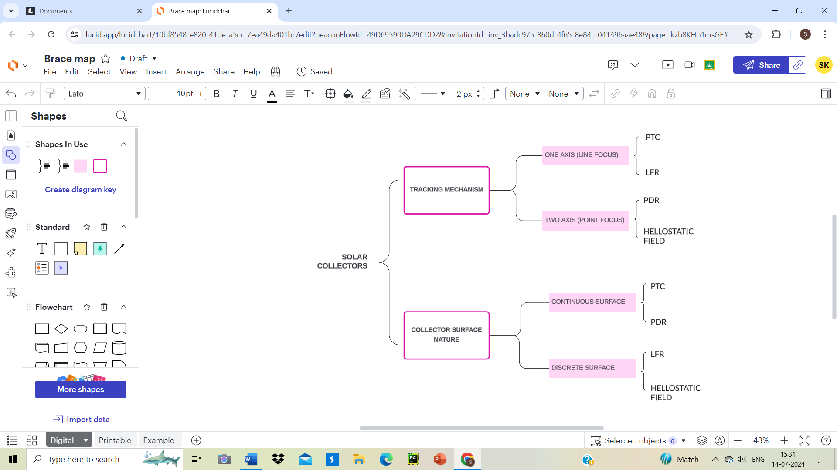

Figure1:

**SoLar Photovoltaic**

Solar photovoltaic (PV) systems use arrays of semiconductor cells, which are additionally known as solar cells, to convert sunlight into electrical power. These cells are put together into modules that fluctuate in size, and they are supplemented by a variety of auxiliary parts that are generally referred to as balance-of-systems (BoS) elements[1]. These devices perform a number of complimentary functions that are essential to the continuous production and consumption of power value chain. PV BoS devices carry out a number of auxiliary functions, including mechanically constructing and attaching solar cells to panels, chemically protecting the cells, producing auxiliary power, inverting power, electrochemically storing electrical power, and monitoring and managing charge.

**COncentratedSolar PowEr**

Concentrated solar power systems use the sun's energy to power collecting equipment, which is how they produce thermal power. Specifically, tracking systems are used to position collectors so that direct solar radiation impingement occurs on their outside surfaces[1]. The suns’ rays are then directed toward a receiver, which is made up of a heat transfer fluid (HTF)-filled pipe network that transports the thermal-Energy produced by the absorber, which converts solar radiation into useful thermal energy. Subsequently, the HTF is directed towards either a heat engine, which transforms the acquired solar heat into electrical power, or (TES) device, which stores thermal-energy for future use.

**Wind Energy**

Wind turbines are meant to harness the kinetic energy of moving air and transform it into electrical power. Power is produced by the wind flowing over specifically made blades that rotate a shaft that is coupledwith a generator deep the Turbine[1]. The location of wind turbines—whether onshore or offshore—as well as their rotational axis set them distinct. This ground-breaking technology serves as a vital contribution to sustainable power solutions by converting the wind's inherent motion into a renewable energy source.

This Chapter covered a variety of technical, social, and environmental implications of wind energy grid integration, and these aspects stood out among the others. To alleviate these generation-level problems, it is indispensable to accurately estimate the wind farm's availability and speed profile, which guarantees that the system's quantitative energy production is known every time. But accurate information about the pattern of consumer energy demand is needed. These information would demonstrate how the energy surplus or deficit of the system is directed toward putting the necessary technical measures in place to smooth out output power[3].

ReneWable_plant_investors and operators are frequently forced to transmitS wind electricity across great distances, which results in significant losses and weak grids, in addition to uneven supply and smoothing issues. Therefore, this section discusses the numerous strategies that are frequently used to mitigate these issues in grid applications of wind energy plants.

**BiOmass EnergY**

"Biomass" is an umbrella title for any natural material that is produced by the breakdown of organic matter and the cellular processes of living things. Typically, these materials are categorized depending upon where they come from: biomass from forests, agricultural residues, and renewable waste products, such as municipal and industrial debris. Forest biomass frequently includes raw forest woods and residues, whereas agricultural biomass typically includes rotation crops& energy as well as their residues. Depending on where they come from and how they are processed, biomass resources might appear as solid, liquid, or gas[1]. Nonetheless, there is a generally accepted belief that solid biomass is the most often utilized form of biomass because it is the most abundant form of the resource.

The products that will be generated from the transforming of biomass often lead to the division of conversion processes into biochemical and thermochemical categories. To create desired products, biomass resources must be fermented or digested through a process known as biochemical conversion. In the absence of oxygen, digestion can be either anaerobic or aerobic. Conversely, heat is engendered at first hand by thermochemical biomass conversion processes. Biomass conversion technologies include pyrolysis (including liquefaction), combustion, and gasification. Despite the fact that both hydroThermal and hydrolYsis processes have received equal attention in the literature, both are downplayed here[2]. It is possible to use the hot flue gases generated during combustion to power secondary heat exchangers that produce steam and electricity. As an alternative, these gasses can be burned directly for specific reasons in a technique called direct combustion. Furnaces, dryers, furnaces, and stoves are examples of devices that are commonly used in the plant matter ignition method.

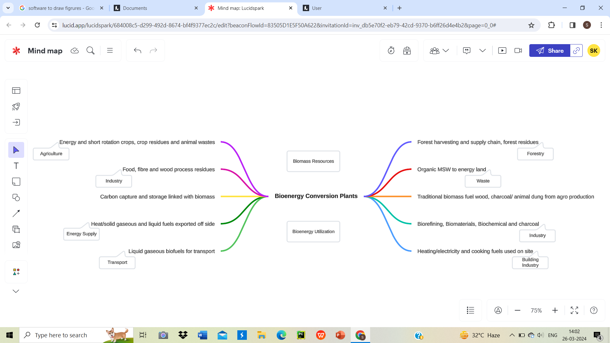

Figure 2:

Pyrolysis is a process that uses biomass and happens without oxygen to convert it into liquid, gas, and charcoal. This adaptable technique enables the setting of parameters to give particular products production priority. Liquification is the process by which liquid biofuels are primarily produced during pyrolysis, for example, when temperatures are raised quickly. On the other hand, a slower rate of heating yields more charcoal. In addition, the accompanying figure shows different methods of transforming solid biomass into these forms[3].

**Geothermal Energy**

Originating from the Greek terms "thermal," which means heat, and "geo," which means earth, the phrase "geothermal energy" relates to heat that rises from underneath the surface of the Earth. Geothermal reservoirs, which are naturally occurring aquifers where water becomes heated by geological processes occurring deep under the Earth's crust, are the source of this energy. Specifically, heat is produced in the mantle and core of the Earth and is transported to these reservoirs via profound crustal fissures. Geothermal resources are regularly supplied and consequently rarely depleted since heat is continuously produced and rises from the Earth's interior. In view of this, geothermal energy is a dependable and sustainable power source. Geothermal energy is an environmentally sustainable resource that may be used for direct heating, cooling, and power generation. It is a trustworthy source of energy that can be included into a more resilient and varied energy mix. Its value in global energy policies is further enhanced by its ability to offer stable, base-load power.

Reservoir sustainability is the main problem with grid-integrated thermal energy systems. These problems result from impurities in the geothermal fluid that sometimes create blockage, as well as differences in the thermodynamic characteristics of the re-injected reservoir fluid, such as temperature and mass flow rates[4]. Threats to the sustainability of reservoirs include the selection of geothermal well sites (due to limits on location suitability) and the availability of cooling facilities, both of which come with hefty expenses associated with design and feasibility studies.

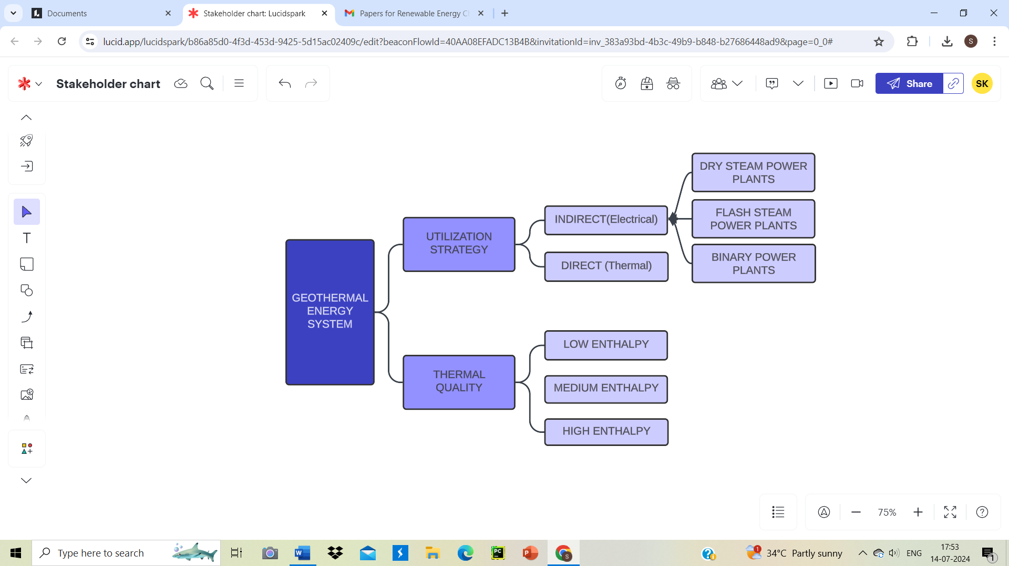

**Renewable-Hydrogen &Fuel CeLL**

Hydrogen, the most prevalent element in the universe, is limited to other elements on Earth and can be found in liquids, hydrocarbons, and other compounds. Although it has long been utilized in the chemical and petrochemical industries, it has only lately been considered a viable energy source. In this regard, practical demonstrations and worldwide research are now underway. Hydrogen has various applications in the energy industry[1].

Research on the grid integration often ignore some features of the generating stack, such as the physical properties of compounds, compressors motion, or air flow. On the other hand, real distributed power networks rely on the intricacies of the previously described stack aspects, and a constant power foundation is necessary for the overall stable operation of the power system. A robust control system with a realistic technical interface with the power grid and detailed modeling of the stack's component pieces is necessary to enhance fuel cell system connection to the grid[7].

**Difficulties with Technological Integration**

To bestow a steady and predictable electricity supply, integrating energy sources into current power systems poses a number of technological obstacles.The primary reason for these challenges is the unpredictable and irregular characteristics, like solar and wind power. A number of technological challenges need to be solved before the full potential of energy can be realized.

**Sustainable Energy's Inconsistency and Variance**

Particularly solar and wind power, renewable energy sources are by their very nature unstable and unpredictable. The sun's intensity changes with the day and the weather, but wind speeds can change dramatically. The output of energy fluctuates as a result of these variations, making it challenging to maintain a steady supply and demand balance.

To get around this problem, grid managers are turning to increasingly advanced forecasting models that provide real-time estimates of the generation of renewable energy. These models incorporate weather forecasts, historical energy generation trends, and data from sensor networks to predict fluctuations and adjust grid operations accordingly. Furthermore, the geographic diversity of renewable energy installations can mitigate local variations in generation.

**Modernizing the Power System and Upgrading the Network Infrastructure**

It is frequently necessary to make significant grid infrastructure upgrades in order to integrate renewable energy sources into current power systems. The primary purpose of conventional grids was to transfer electricity from centralized power plants to end users in a one-way fashion[12].

On the other hand, since consumers can also become producers, renewable energy systems—particularly dispersed wind turbines and rooftop solar panels—introduce two-way energy flow. In order to modernize the grid, smart grid technologies that provide bidirectional energy flow, automated reactions to grid disruptions, and real-time monitoring. This calls for a lot of expenditures on grid infrastructure, such as the setting up of cutting-edge sensors and communication networks, and systems of control. Additionally, grid operators need to create reliable protocols for distributed energy management .resources while keeping the grid stable.

**Problem with Electrical safety and reliability**

Grid reliability and electrical quality may be impacted by the unpredictability of renewable energy sources. Voltage swings and frequency aberrations brought on by abrupt changes in energy generation have the potential to damage sensitive equipment and cause blackouts[17].

To address concerns with power quality, grid operators use complex voltage and frequency regulation systems. Two examples of energy storage technologies that are necessary to lessen oscillations and ensure that consumers receive a continuous supply of electricity are batteries and pumped hydro storage. In addition, standards and conventions pertaining to the grid are evolving to facilitate the incorporation of renewable energy sources and define acceptable standards for electricity quality.

**Demand-Reaction Systems and Intelligent Grids**

Demand-driven control and intelligent grid technologies have become vital for improving the flexibility and efficiency of power networks. Users can adjust to price signals or grid circumstances by using demand response programs. Like when the output of renewable energy is high, consumers might be incentivized to utilize more energy or store more energy[23]. Smart grids facilitate real-time communication between dispersed energy resources, consumers, and grid operators. They enable automatic response to grid events such as load shedding and boost renewable energy generation. Smart grids optimize resource consumption and coordinate responses to support grid stability and resilience.

**Issues with the Financial and regulations area**

Introducing renewable energy into electricity systems entails overcoming legal, financial, and technical obstacles. Stakeholders can establish an environment that is conducive to the smooth implementation of clean energy solutions and guarantees a more stable and sustainable energy future by tackling financial and legal barriers.

**Economic Framework along with expenses implications**

One of the primary financial barriers to the integration is the cost of updating grid infrastructure and putting renewable energy technology into practice. Even if the cost of renewable technologies, such as solarpanels and wind Turbines, has significantly decreased recently, there are still upfront expenses related to their installation and upkeep.

The finance strategies employed in renewable energy projects play a major role in their financial viability. To reduce the financial burden on producers and users of renewable energy, governments, private investors, and financial institutions routinely offer incentives, subsidies, and financing choices[2]. These instruments include feed-in tariffs, power purchase agreements (PPAs), tax credits, and green bonds. Effective financing may speed up the implementation of renewable energy projects and ease the transition to cleaner energy sources.

**Regulation and Policy Obstacles**

The integration of renewable energy is greatly impacted by national, state, and local policy and regulatory frameworks. Regulations that are out-of-date or inconsistent might make it difficult for renewable energy projects to get started and grow. Permitting procedures, interconnection requirements, and land use laws are examples of regulatory obstacles[3]. In order to get past regulatory obstacles, it is imperative to streamline these procedures and provide precise instructions for the construction of renewable energy projects. In addition, by putting in place carbon pricing mechanisms, imposing strict renewable portfolio standards, and setting high goals for renewable energy, governments can foster favorable settings.

**Market. Organization and Cost of power**

The existing power pricing and market practices can have a significant impact on the financial stability of renewable energy projects. Since traditional electricity markets are often based on centralized power generated by petroleum facilities, they may not be able to successfully integrate renewable energy sources. Transitioning to market mechanisms that reward flexibility and grid services is essential. With the use of mechanisms like capacity markets, auxiliary service markets, and time-of-use pricing, renewable energy producers can be encous Averaged to contribute to grid stability. Market changes that appreciate the environmental benefits of renewable energy and account for the external costs of fossil fuels are also required in order to align economic incentives with sustainability objectives.

**Encouragements for the Use of Green Energy.**

Incentives for companies and individual consumers to adopt green power are the primary factor influencing the growth of capacity for green energy. These incentives can take many different forms, including net metering rules, tax deductions, repayments, and special feed-in prices. By providing strong incentives, renewable energy adoption should be promoted while maintaining sound financial practices. Periodic reviews and adjustments to incentive programs are necessary to ensure that they are in line with evolving market conditions and technical advancements.

**Areas Available for Technology**

Although integrating renewable energy into the current electricity infrastructure comes with its own set of challenges, there is a lot of room for creativity. The long-term viability reliability, and effectiveness of the electrical environment will all be enhanced by these advancements.

**Alternatives for preserving energy.**

Optimizing the stability of renewable energy sources requires significant progress in energy storage technologies. Batteries, pumped hydro storage, thermal storage, and other solutions are essential for controlling the unpredictability of renewable energy sources. By retaining extra energy produced during times of high production and releasing it when demand outweighs supply, these systems guarantee a consistent and reliable power supply. Through the regulation of energy supply and demand, various storage technologies serve to the ongoing supply of renewable energy.

Recent developments in battery_technology have led to improvements in cost-effectiveness, cycle life, and energy density. In particular, advances in lithium-ion batteries make them a viable option for both home and grid-scale energy storage. Additional investigation into state-of-the-art technologies, like solid-state and flow batteries, may enhance energy storage even more.

**Technological Developments in Network Maintenance**

Significant opportunities exist for boosting the integration of renewable energy sources with advanced grid management systems and smart grid technology. Due to these advancements, energy flows can be monitored and controlled in real time, which enables grid managers to promptly adjust to variations in energy generation and demand. The integration of renewable energy sources into the grid can be made much more reliable and efficient through the implementation of these technologies.

Customers can actively participate in grid balancing thanks to demand response management, which is made viable by Smart-Meters and communication networks. Consumers who adjust their power-consumption in response to price signals or other grid conditions can contribute to load management and grid stability.

**Micro-grids along with Decentralized Transmission**

The scattered nature of renewable energy sources opens the door to micro grids and distributed generating models. Distributed production is the term used to describe electricity generated atpoint of consumption. This concept reduces transmission losses and enhances-energy-security. Micro grids are small, distributed energy systems that can work alone or in concert. They are particularly helpful in remote or off-grid areas and can provide resilience in the event of grid breakdowns. When paired with the production of renewable energy, improvements in micro grid control systems offer opportunities for enhanced energy independence and dependability.

**Equipped with electric automobiles**

The growing popularity of electric vehicles presents a unique opportunity to integrate renewable energy. Because EV can act as mobile energy storage units, energy can be transferred between vehicles and the grid. Electric vehicles (EV) can supply extra energy back into the grid during high demand or serve as backup power sources during blackouts thanks to V2G (vehicle to grid) technology.

Adding EV to the energy environment creates a win-win link between transportation and power generating. This innovation could reduce the need for additional grid capacity, increase system reliability, and facilitate the use of green energy sources for mobility.

**Consequences for the Environment and Society**

Beyond just the technical and financial, the integration of green energy sources into the current power systems has a substantial ecological and social impact. Developing comprehensive and environmentally friendly electricity strategy requires an understanding of these ramifications.

**Growth in the Economy as well as Employment**

Building wind turbines or solar farms is one example of a renewable-Energy work that has the potential to create a large number of jobs. The renewable energy sector is acknowledged for its labor-intensive nature, with a workforce that comprises a wide range of skill levels and occupations.

Investing in renewable energy can strengthen local, state, and federal economies. These projects require supplies of materials, equipment, and services, which generates economic activity that impacts supply chains. Furthermore, there are always jobs available in the maintenance and running of renewable energy installations.

**Prevention of emission of greenhouse. Gases**

One of the primary environmental benefits of integrating renewable energy is the decrease in greenhouse gas emissions. When fuel-based electricity generation is replaced with renewable energy sources, greenhouse gas emissions are decreased.

Public health and air quality improve as a result of lower emissions of methane, carbon dioxide, and other pollutants.

The move is consistent with international climate agreements and commitments to mitigate global warming. It supports programs aimed at achieving net-zero emissions and carbon neutrality in the energy sector.

**Reliability of Power & Agility**

Energy security is increased when renewWable-energy is included since it diversifies the energy supply mix. Renewable-Energy sources are plentiful and non-depletable, in contrast to fossil fuels, which are restricted to domestic availability, subject to price swings, and influenced by geopolitical tensions. This reduces reliance on external energy sources and increases energy independence.

Energy security and grid resilience are enhanced by renewable energy. In the event of a cyberattack or other grid disruption, backup power can be provided by micro grids and distributed energy resources. Communities that have resilient energy systems are better able to withstand shocks and bounce back faster.

**Public View & Acknowledgement**

The acceptance of green energy projects by society is a prerequisite for their successful implementation. The willingness of a community to embrace renewable energy projects, such as turbines and photovoltaic lists, may have an effect on the project's results.

Effective community engagement and consultation procedures are essential to finding solutions and gaining support. Openness in project planning, equitable benefit distribution, and consideration of local consequences like noise and aesthetics are factors that affect public acceptability and perception.

**Smart Grid Technology’s Benefits for Renewable Energy Integration**

As the idea of integrating Renewable-Energy-Sources gets traction, a dependable and efficient energy infrastructure becomes more and more important. This is where smart grid technology comes in handy. Since smart grids provide an integrated approach to energy management and distribution, they are the ideal solution for integrating renewable energy sources.

**Enhanced Cost-Effectiveness**: Smart grid technologies provide more efficient energy distribution and administration. Since it allows them to track and manage energy usage in real-time, energy companies are able to identify and solve problems quickly. With intelligent grid technologies, energy from renewable sources can be distributed to areas with high energy demand. This ensures effective energy use and makes managing the energy supply easier. As a result, smart grid technology reduces energy waste and promotes the efficient use of energy from renewable sources.

**Effectively Connectivity of Green Energy Source**: One of theadvantages of a smart grid technology is its aptness to better integrate reneWable energy sources, such as hydroelectricity, solar power, and wind energy. Controlling energy distribution is difficult since renewable-energy-sources are intermittent and distributed. Conversely, smart grids ensure the efficient use of renewable energy sources by easily managing their flow. Thanks to smart networks, energy companies can store excess energy of low demand and redistribute it during times of high need. This improves the efficiency of energy distribution as well as the stability and dependability of the power grid.

**Economical**: Smart grid technology turns out to be financially beneficial over time. Thanks to technology, energy companies may now improve energy distribution, reducing energy waste and increasing grid efficiency. As a result, this reduces the overall cost of energy delivery and production. Renewable energy sources can help energy companies reduce their dependency on fossil fuels, which are becoming more and more expensive. By using smart grid technologies, energy companies may also foresee and avoid equipment breakdowns, reducing the need for costly repairs and replacements.

**Higher Dependability**: Smart grid technologies increase the dependability of the electrical system. By continuously monitoring the electricity grid, it enables energy companies to quickly identify and fix faults in the system. Smart grids allow energy corporations to better control the distribution of energy since they ensure that the power system remains stable even during high demand. This increases the reliability of the gridS and reduces the likelihood of power outages.

**Ecological Advantages**: Smart grid technology has numerous positive effects on the environment. Renewable energy sources can help energy companies reduce their footprint and promote the development of sustainable energy. ReneWable-Energy sources reduce air pollution and are healthier than fossil fuels. They are also more environmentally friendly. Smart grid technology, which reduces energy waste and promotes the optimal use of energy resources, also gives energy corporations more control over how energy is distributed.   
  
Intelligent grid technology is required to incorporate reneWable energy sources into the electrical infrastructure. In addition to reducing energy waste, increasing energy distribution efficiency, and supporting the effective use of renewable-Energy sources, it provides an integrated approach to energy management and distribution. Furthermore, through reducing the likelihood of blackouts and promoting the production of sustainable energy, smart grids increase the dependability of the power system. Because there is an increasing need for sustainable energy generation, smart grid technology is becoming more and more significant in the energy sector.

**Conclusion**

The integration of sources into existing power infrastructures is at the forefront of the global energy revolution. Our motivation for this voyage stems from the need to prevent climate change, reduces greenhouse gas emissions, and guarantee a sustainable energy future.

The challenges of integrating renewable energy must be addressed by the continued application of technological innovation. To increase the dependability and adaptability of electrical infrastructure, demand-side responses, energy preservation, and network management tools must be developed.

The development of legislative frameworks and economic models that advance the goals of renewable energy is crucial. Legislation that supports green energy, changes in marketplaces, and effective funding sources all speed up the adoption of this technology. Both humanity and the environmentbenefit greatly from the use of sources of clean energy. Benefits include improved air quality, more jobs, less emissions of carbon dioxide, and energy security.

Future green energy integration will be characterized by expedited execution, electrified transit, clean hydrogen the next, global cooperation, and ongoing technological innovation. These advancements show the path to a more resilient and sustainable energy system.Integrating renewable energy into existing power systems requires more than simply technical or financial know-how; rather, it requires a community commitment to a more ethical and sustainable energy future. Governments, corporations, communities, and individuals must work together.

The degree to which renewable energy is successfully integrated will have a significant impact on the energy landscape going forward. The journey is worthwhile, and the destination guarantees a brighter, environmentally friendly, and safe future for generations to come.

**References:**

[1] Joseph Oyekale and Mario Petrollese.Impacts of Renewable Energy Resources on Effectiveness of Grid-Integrated Systems: Succint Review of Current Challenges and Potential Solutions Strategies Energies 2020, 13, 4856; doi:10.3390/en13184856

[2] Rajini K R Karduri. Integrating Renewable Energy into Existing Power Systems: Challenges and Opportunities, Vol. IV, Issue III, March 2018

[3] Renewable Energy Integration in Power Grids, [www.etsap.org](http://www.etsap.org)

[4] Saianiruth Matura Pragash.Smart Grid Technology and its Impact on Renewable Energy Integration, Volume XX, 2017

[5] Muhammad Khalid. Smart Grids and Renewable Energy Systems: Perspectives and Grid Integration Challenges, Energy Strategy Reviews 51 (2024) 101299

[6] Bogdan Marinescu, Oriol Gomis-Bellmunt. Dynamic Virtual Power Plant: A New Concept for Grid Integration of Renewable Energy Sources, Volume 10, 2022

[7] Bethany Speer and Mackay Miller. The Role of Smart Grids in Integrating Renewable Energy, Annex 4, Task 3.2

[8] Emmanuel Hache and Angelique Palle. Renewable Energy Source Integration into Power networks, research trends and policy implications: A bibliometric and research actors survey analysis 2019, 124,pp.23-35.

[9] Mubashir Hussain Rehmani and Martin Reisslein. Integrating Renewable Energy Resources into the Smart Grid: Recents Developments in Information and Communication Technologies IEEE Transactions on Industrial Informatics,Vol. 14, No. 7, July 2018

[10] IEA. World Energy Outlook 2019; IEA: Paris, France, 2019; ISBN 2025869592.

[11] Sansaniwal, S.K.; Sharma, V.; Mathur, J. Energy and exergy analyses of various typical solar energy applications: A comprehensive review. Renew. Sustain. Energy Rev. 2018, 82, 1576–1601.

[12] Shariatzadeh, Navid, and Mohammad Shahidehpour. "Smart grid technology and its applications." Electric Power Systems Research 143 (2017): 514-523.

[13] K. N. Naik, P. Kundu, and R. K. Nema, "Smart grid communication and information technology: A review," IEEE Transactions on Smart Grid, vol. 5, no. 4, pp. 1752-1763, July 2014.

[14] Y. Yang, H. Mohsenian-Rad, and R. Schober, "Smart grid communication: Overview of research challenges, solutions, and standardization activities," IEEE Communications Surveys and Tutorials, vol. 15, no. 1, pp. 21-38, January-March 2013.

[15] R. H. Lasseter, "Smart distribution: Coupled microgrids," Proceedings of the IEEE, vol. 99, no. 6, pp. 1074-1082, June 2011.

[16] Islam, A. K. M. Zahidul, "A review of smart grid technologies and applications: Opportunities and challenges." Renewable and Sustainable Energy Reviews 60 (2016): 1127-1145.

[17] Huang, Hong,"Smart grid: concept and challenges." IEEE Transactions on Industrial Electronics 56.10 (2009): 4255-4265.

[18] Han, Jinyun,"Renewable energy integration: current status and future directions." Journal of Renewable and Sustainable Energy Reviews 15.1 (2011): 118-144.

[19] Zhang, Xi, "A review of energy storage technologies for grid applications." Energy Procedia 75 (2015): 2690-2695.

[20] Watson, J.; Zhang, Y.; Si, B.; Chen,W.-T.; De Souza, R. Gasification of biowaste: A critical review and outlooks. Renew. Sustain. Energy Rev. 2018, 83, 1–17.

[21] Chaubey, R.; Sahu, S.; James, O.O.; Maity, S. A review on development of industrial processes and emerging techniques for production of hydrogen from renewable and sustainable sources. Renew. Sustain. Energy Rev. 2013, 23, 443–462.

[22] Ouedraogo, B.I.; Yamegueu, D. Techno-economic assessment of solar photovoltaic integration into national grids: A case study of Burkina Faso. Energy Sci. Eng. 2019, 7, 1458–1468.

[23] Archa G.Mahira and Mansi S. Subhedar, “Handover Decision in Wireless Heterogeneous Networks Based on Feedforward Artificial Neural Network.In: Behera, H., Mohapatra, D. (eds) Computational Intelligence in Data Mining. Advances in Intelligent Systems and Computing, vol 556. Springer, Singapore. <https://doi.org/10.1007/978-981-10-3874-7_63(2017)> PP 663-669.”

[24] Mansi S. Subhedar and Vijay H. Mankar, “Curvelet transform and cover selection for secure steganography. Multimed Tools Appl 77, 8115–8138 (2018). <https://doi.org/10.1007/s11042-017-4706-x>.”

[25] Mansi Subhedar and Gajanan Birajdar, “Spectrum Sensing techniques in Cognitive radio networks: A Survey” International Journal of Next-Generation Networks (IJNGN) Vol.3, No.2, June 2011.

[26] Mansi S. Subhedar and Vijay H. Mankar, “Current Status and Key issues in image steganography: A Survey” Volumes 13–14 November 2014, Pages 95-113.

[27] Parikshit Mahallle and Antonietta Stango, “Proposed security model and threat taxonomy for the Internet of Things (IoT)” CNSA 2010, Chennai, India, July 23-25, 2010.

[28] Arvind Deshpande, Parikshit Mahalle, “Data Stream Clustering Techniques, Applications, and Models: Comparative Analysis and Discussion” Big Data Cogn. Comput. 2018, 2(4), 32; <https://doi.org/10.3390/bdcc2040032>.

[29] Parikshit N Mahalle, Bayu Anggorojati, “Identity authentication and capability based access control (IACAC) for the internet of things(2013).”

[30] Pranav Pawar, Rasmus Nielsen, “Hybrid mechanisms: Towards an efficient wireless sensor network medium access control(2011).”

[31]  Pranav Pawar, LM Waghmare, “Comparison and performance evaluation of wireless sensor network with different routing protocols(2011).”

[32]  Pranav M Pawar, Raja Muthalagu, “Efficient intelligent intrusion detection system for heterogeneous internet of things (HetIoT) 2023.”