**Forensic Fingerprinting: A fascinating historical journey from Bengal**

**Dr. Pranav Kumar, IPS**

**Additional Commissioner of Police (II), Kolkata Police,**

**Lalbazar, Kolkata-700001**

**drpranav97@gmail.com**

**ABSTRACT**

The use of fingerprinting for forensic purposes originated in colonial India towards the end of the nineteenth century, particularly in the Bengal province of colonial India, before gradually spreading across the world. This article traces the remarkable journey of fingerprinting, linking its early roots in traditional practices of authentication to its emergence as a cornerstone of modern scientific investigation. Situating the developments in Bengal within the broader global trajectory of fingerprint identification, the article highlights several early and significant cases where fingerprinting was first applied to criminal investigations. These cases played a pivotal role in the legal and scientific evolution of fingerprinting as a forensic tool. As India advances towards a nationwide automated fingerprint identification system leveraging information technology, this historical account offers a compelling perspective on the transformation of traditional knowledge into an enduring instrument of modern law enforcement.

Key words: Fingerprinting, forensic, crime, investigation

**I. INTRODUCTION**

The pursuit of justice and the endeavour to bring offenders to account is an age-old aspiration of human society. Forensic fingerprinting, a vital tool in this pursuit, builds upon traditional practices of using physical impressions for authentication and identity verification. Fingerprints are impressions formed by the ridges and furrows present on the tips of fingers and thumbs. Owing to the uniqueness of these ridge patterns in every individual, fingerprints have long been regarded as an infallible means of identification.

Today, fingerprint identification systems have become ubiquitous. From fingerprint scanners on smartphones to biometric authentication systems in businesses and government institutions, fingerprints are employed widely as a quick and reliable method of identification and verification. However, the use of fingerprinting for forensic purposes has a rich and fascinating history. Latent fingerprints left at crime scenes provide investigators with crucial leads, enabling the identification of suspects and the presentation of incontrovertible evidence during trial proceedings.

The forensic use of fingerprints began in earnest towards the end of the nineteenth century and quickly gained acceptance across the world. The 125th anniversary of the Fingerprint Bureau of the Criminal Investigation Department, West Bengal—believed to be the oldest such bureau in the world—celebrated in 2022, offers an opportune moment to revisit and reflect upon the remarkable journey of fingerprinting, from its modest beginnings to its establishment as a cornerstone of modern criminal investigation. The transformation of an ancient traditional practice into a codified and scientific method of forensic identification exemplifies the deep and often overlooked connections between indigenous knowledge and modern legal systems[1].

**II. ANCIENT WORLD**

The practice of recording fingerprints for authentication purposes can be traced back to ancient civilizations. Archaeological evidence from Mesopotamia, dating as early as 3000 BCE, reveals the earliest purposive impressions of fingers, notably on bricks used in the construction of the King's storehouse. Similar instances of fingerprint impressions have been discovered in ancient Egypt, suggesting that the use of fingerprints for official purposes may have been more widespread than previously assumed.

In Babylon, during the reign of Hammurabi (second millennium BCE), finger seals were reportedly used to authenticate contracts. Some historical accounts even suggest that fingerprints of individuals arrested for crimes were recorded, although the extent and systematic nature of this practice remain unclear.

The earliest documented use of fingerprints for individual identification, however, appears to have occurred in ancient China. Government documents were authenticated through fingerprints, and a clay seal from the third century CE bears a left thumb impression, indicating the purposive use of fingerprints for official validation. Following the invention of paper, it became customary in China to record palm prints, lower finger joint marks, or full fingerprints on legal contracts to ensure authenticity.

As far as criminal justice procedures are concerned, a Chinese text from the Qin Dynasty (221–206 BCE), titled *The Volume of Crime Scene Investigation—Burglary*, references the collection of handprints from crime scenes as a form of evidence. During this period, both handprints and footprints were systematically gathered from locations where crimes had been committed.

Further corroboration comes from the writings of Rashid-al-Din Hamadani (1247–1318), an Iranian physician and historian, who remarked on the use of fingerprints for identification in China. He observed, "*Experience shows that no two individuals have fingers exactly alike*," an early recognition of the uniqueness of fingerprints. However, it remains uncertain whether ancient Chinese officials fully understood the scientific principle of fingerprint individuality or whether their reliance on fingerprints was based primarily on tradition and practical experience.

**III. FINGERPRINTING IN MEDIEVAL INDIA**

In medieval India, there is evidence to suggest that the practice of using fingerprints for authentication, possibly influenced by Chinese traditions, was known among the nobility. Impressions of friction ridge skin were employed as distinctive signatures to validate documents and agreements.

During the Mughal period, the use of a royal hand impression as a mark of supreme authentication emerged as a notable practice. The biography of Mughal Emperor Jahangir records that following the defeat of the Udaipur ruler Amar Singh Sisodia, the latter demanded, as a condition of the treaty, a royal hand impression from the emperor to authenticate the agreement. A similar instance is noted in the case of Shahaji Bhosle, the father of Shivaji, who, after his defeat by the Mughal army under Emperor Shah Jahan in 1637 CE, sought a written treaty stamped with the emperor’s hand impression.

These examples illustrate that the use of hand impressions—akin to fingerprints—as a means of authenticating important documents was already embedded within the administrative and diplomatic practices of medieval India. Although the scientific understanding of fingerprint uniqueness was absent, the cultural significance of using the human hand as an unmistakable mark of authority and authenticity was well established.

**IV. FINGERPRINTING IN MODERN WORLD**

As Europe transitioned from the medieval period to modernity through the Renaissance, the study of fingerprints began to attract the attention of anatomists and scientists interested in human physiology. The first detailed observations of friction ridge skin were recorded in 1684 by Nehemiah Grew, an English physician and plant morphologist, who described the intricate patterns of ridges and furrows on the surfaces of fingers in the Philosophical Transactions of the Royal Society of London.[2]

Subsequent developments deepened scientific understanding of fingerprints. In 1788, German anatomist Johann Christoph Andreas Mayer, in his work Anatomical Copper-Plates with Appropriate Explanations, asserted that the friction ridge skin was unique to each individual. Mayer’s publication included detailed drawings of fingerprint patterns, marking a significant step toward the recognition of individuality in fingerprints. In 1823, Czech anatomist Jan Evangelista Purkyně further advanced the study by identifying nine distinct fingerprint patterns, laying an early foundation for classification systems. The transition of fingerprinting from anatomical curiosity to forensic application can be largely attributed to the efforts of Henry Faulds, a Scottish physician working as a medical missionary at a hospital in Tokyo. In a letter dated October 28, 1880, published in Nature magazine, Faulds described the unique and permanent patterns of fingerprints and proposed their use in criminal identification. He also suggested practical methods for recording fingerprints using printer’s ink. Upon his return to Britain, Faulds offered his techniques to the London Metropolitan Police between 1886 and 1888, even proposing to establish a fingerprint bureau at his own expense. However, his proposals were not accepted, and Faulds did not receive due recognition during his lifetime for his pioneering contribution.

A major leap occurred with the publication of Finger Prints by Sir Francis Galton in 1892, the first comprehensive scientific study on the subject. Galton introduced a system for fingerprint classification based on three major pattern types—arches, loops, and whorls—and statistically calculated the improbability of two individuals having identical fingerprints as approximately one in sixty-four billion. Despite Galton's significant contribution to establishing fingerprints as a scientific method of identification, anthropometry—the measurement of human body parts—continued to be the dominant method of criminal identification across England, Europe, and the Americas during the latter part of the nineteenth century.

In 1893, the Troup Committee, constituted in England to examine methods of personal identification[3], acknowledged the potential of both anthropometry and fingerprinting. However, given the lack of a reliable classification system for fingerprints at the time, the Committee recommended the concurrent use of both methods. These recommendations influenced practices not only in England but also in colonial India, where fingerprinting would soon take a decisive turn. Meanwhile, significant advancements were taking place elsewhere. In Argentina, Juan Vucetich, a statistician with the Central Police Department in La Plata, introduced the first systematic recording of criminals' fingerprints in 1891 and developed his own classification system. This marked the first practical use of fingerprinting by a law enforcement agency. Vucetich later published his seminal work Dactiloscopia Comparada ("Comparative Fingerprinting") in 1904, which became a foundational text for fingerprint science in Latin America.

In France, René Forgeot, a forensic expert, proposed in 1891 the use of powders and chemicals to develop latent fingerprints on objects at crime scenes, thus enhancing their utility for forensic identification.

In the United States, early recognition of fingerprint potential can be traced to a lecture by one Thomas Taylor in 1877, which was reported in the July 1877 issue of the American Journal of Microscopy and Popular Science. Taylor had referred to the possibility of "*identifying criminals by comparing marks on the hands left upon any object with impressions in wax taken from the hands of suspected persons*".[4] The lecturer further expressed the opinion that "*in case of murderers, the marks of bloody hands would present a very favourable opportunity*". However, practical application of fingerprinting in the United States took several decades to materialize[5]. One of the earliest recorded uses was by geologist Gilbert Thompson in 1882, who used his own fingerprint to sign cheques in New Mexico, preventing forgery.

It was only in the early twentieth century that fingerprinting gained systematic acceptance in American law enforcement. In 1902, Dr. Henry P. DeForrest, a surgeon associated with the New York City Police Department and the City Civil Service Commission, pioneered the organized use of fingerprints to prevent impersonation in civil service examinations. This initiative laid the groundwork for the broader adoption of fingerprint identification systems across the United States.

V. **USE OF FINGERPRINTS IN COLONIAL INDIA**

The formal use of fingerprints for official purposes in colonial India is closely associated with Sir William James Herschel, an administrator with the East India Company who later joined the Indian Civil Service. In 1858, while executing a contract for the supply of road-building materials in Bengal, Herschel obtained a hand impression from Rajyadhar Konai, a local businessman, to validate the agreement. This is often regarded as one of the earliest official uses of fingerprint authentication in India. Subsequently, in 1877, Herschel institutionalized the practice of recording fingerprints for authenticating contracts and initiated the registration of pensioners' fingerprints to prevent fraudulent claims after their deaths.[6]

Herschel later chronicled his experiences in his book Origin of Fingerprinting (1916), asserting that Rajyadhar Konai’s signed contract represented the first official use of fingerprints for authentication. However, this claim has been contested, given historical evidence of earlier practices involving hand impressions, such as the “tip sahi (soi)” tradition, where fingerprints were used to validate documents. Nonetheless, Herschel's efforts marked the beginning of a lifelong engagement with fingerprinting. He diligently collected fingerprints from numerous individuals, including friends and family members, and published his own prints over time to demonstrate their permanence.

During his tenure as Magistrate and Collector of Hooghly district, Herschel also proposed the use of fingerprints in prisons to prevent impersonation. In 1877, he wrote the well-known "Hooghly Letter" to the Inspector of Jails and the Registrar General of Bengal, suggesting the formal adoption of fingerprinting for identification purposes. However, his proposals were not immediately accepted, and the limited application of fingerprinting in Hooghly was discontinued after his departure.

A major breakthrough occurred in the 1890s under the leadership of Sir Edward Richard Henry, then Inspector General of Police of Bengal.[7] Working in collaboration with Sir Francis Galton, Henry sought to develop a reliable and systematic method of fingerprint classification. This effort led to the involvement of two Indian police sub-inspectors, Azizul Haque and Hem Chandra Bose, who played a pivotal role in formulating a mathematical classification system for fingerprints. Henry later documented the classification scheme in his book The Classification and Uses of Fingerprints (1900), although the contributions of Haque and Bose were not formally acknowledged in the initial publication.[8]

Subsequent historical accounts suggest that Azizul Haque (later honored as Khan Bahadur and retired as Deputy Superintendent of Police) and Hem Chandra Bose (later awarded the title of Rai Bahadur and also retired as Deputy Superintendent of Police) were instrumental in independently developing the classification system. Following representations made to the British authorities, both officers were awarded an honorarium of Rs. 5,000 each in recognition of their significant contributions. Hem Chandra Bose is further credited with devising a telegraphic code system for transmitting fingerprint data, which was later adopted by Scotland Yard.

In June 1897, the Government of India formally approved the exclusive use of fingerprints for the identification of prisoners, based on the recommendations of a specially constituted committee (Figure 2). The Bengal Fingerprint Bureau, established in the same year and housed in the Writers' Building in Calcutta, replaced the earlier Calcutta Anthropometric Bureau. This institution holds the distinction of being the world's first fingerprint bureau. Sir Edward Henry later became the Chief Commissioner of the London Metropolitan Police, where he introduced the Henry-Galton classification system to Scotland Yard in 1901, leading to the global spread and standardization of fingerprinting practices.

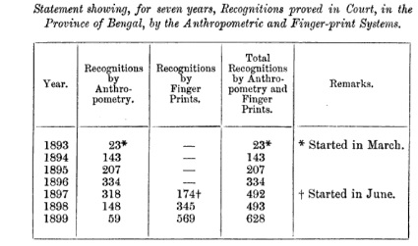

**Figure 1: Use of anthropometry and fingerprinting in colonial Bengal[9]**

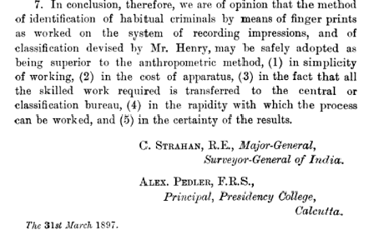

**Figure 2: Final Recommendations of Government Committee to adopt fingerprinting as identification method[10]**

**VI. EARLIEST USE OF FINGERPRINTS IN CRIMINAL CASES**

The potential of fingerprint evidence in criminal investigations began to surface during the nineteenth century, although its acceptance was initially slow. One of the earliest documented instances is associated with the murder of Lord William Russell, a member of the British Parliament, who was found murdered in his bed on 5 May 1840. His valet was suspected of the crime. A provincial doctor, Robert Blake Overton, wrote to Scotland Yard suggesting the collection of fingerprints from the crime scene. Although fingerprints were indeed collected, no further action was taken, and the idea of using them as forensic evidence was largely ignored for the next fifty years (Figure 3).

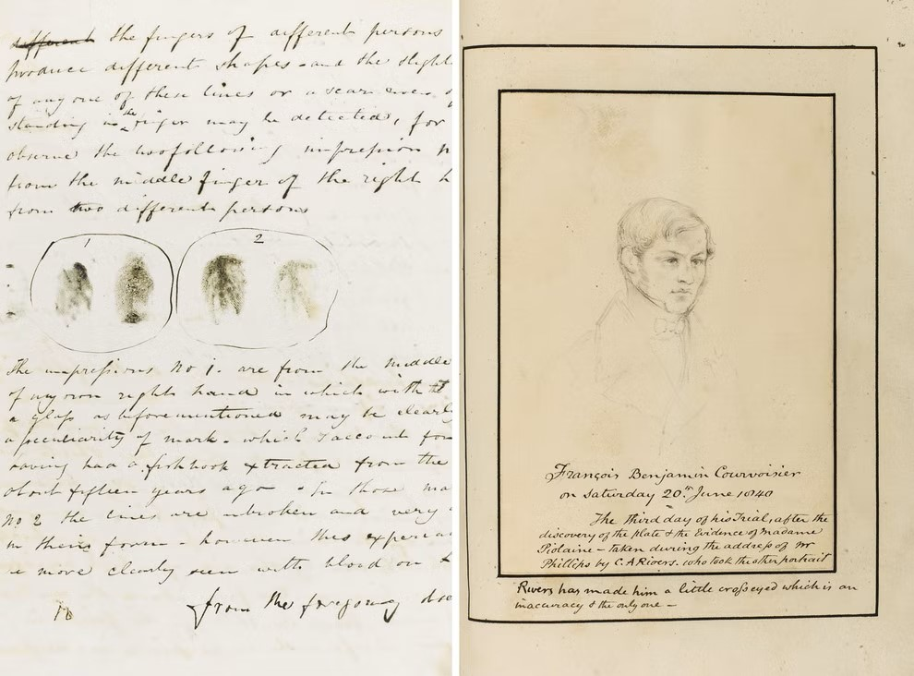

**Figure 3: Letter by Dr. Robert Blake Overton in Lord William Russell murder case[11]**

A major breakthrough occurred in Argentina in 1892 with the case of Francisca Rojas. In a gruesome incident in Buenos Aires, two children were found murdered while Rojas herself sustained a wound to her throat. She accused a man named Velasquez, alleging that he had committed the crime after she rejected his advances. Velasquez, however, refused to confess. During the investigation, Inspector Alvarez discovered a bloody thumbprint on a door at the crime scene. Upon comparison, the thumbprint matched that of Francisca Rojas herself, who later confessed to the murders. The Rojas case is widely recognized as the first criminal case in modern history solved through fingerprint evidence (Figure 4).

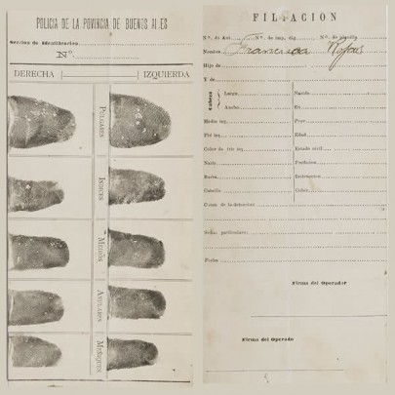

**Figure 4: Fingerprints of Francisca Rojas[12]**

In India, a landmark case involving the use of fingerprints occurred in 1898 in Bengal province. The case involved the murder of a tea garden manager in the Jalpaiguri district. The Criminal Investigation Department of Bengal undertook the investigation, and several individuals emerged as suspects, including a recently released coolie named Kangali Charan, who had previously been imprisoned by the deceased manager on charges of theft.[13]

During the investigation, investigators recovered a calendar from a box belonging to the manager, bearing the fingerprint of a right-hand finger along with brown stains later confirmed to be of mammalian origin. Since Kangali Charan’s fingerprints were already on record with the newly established Fingerprint Bureau, a comparison was undertaken. The fingerprint found at the crime scene matched his recorded prints[14].

The Court accepted the fingerprint evidence and convicted Kangali Charan for theft, although it hesitated to convict him of murder solely on the basis of fingerprint evidence. At that time, there was no statutory provision explicitly recognizing fingerprint evidence. Subsequently, in 1899, the Indian Evidence Act of 1872 was amended to include opinion upon finger impressions under Section 45 as expert evidence (now section 41 of newly introduced Bharatiya Sakshya Adhiniyam, 2023 which replaces Indian Evidence Act, 1872) deals with finger impressions). This was the first statutory recognition of fingerprint evidence anywhere in the world.

In England, the first case resulting in conviction through fingerprint evidence was a burglary case in 1902. Inspector Charles Stockley Collins of Scotland Yard testified regarding the identification made through fingerprint matching, leading to the successful conviction of the accused. Around the same period, developments were taking place across the Atlantic. In the United States, the use of fingerprints in criminal trials began somewhat later. The 1911 case of *People v. Crippi*[15] in New York is considered the first American conviction obtained based solely on fingerprint evidence. In the same year, *People v. Jennings*[16] in Illinois proved to be a landmark case. Thomas Jennings was identified as the murderer of Clarence Hiller after his fingerprints were discovered on a freshly painted railing at the crime scene. The Illinois Supreme Court upheld Jennings' conviction, formally establishing the admissibility of fingerprint evidence in American courts.[17]

**VII. CONCLUSION**

From its modest beginnings, the development and use of latent fingerprints have become an integral component of modern forensic investigation. Technological advancements have significantly enhanced the ability to detect, develop, and analyze latent fingerprints across a wide range of surfaces, thereby expanding their evidentiary value in criminal cases. Today, automated fingerprint identification systems (AFIS) are employed worldwide to facilitate the rapid analysis and matching of fingerprints. In India, the rollout of the National Automated Fingerprint Identification System (NAFIS) marks a major milestone in this evolution. NAFIS enables quick and efficient access to fingerprint databases, thereby strengthening investigative processes and promoting the routine use of fingerprint evidence by law enforcement agencies.

Further reinforcing the role of biometric identification in the criminal justice system, the Government of India enacted the Criminal Procedure (Identification) Act, 2022, replacing the earlier Identification of Prisoners Act, 1920. The 2022 Act significantly broadens the scope of biometric data collection, empowering law enforcement agencies to collect fingerprints, palm prints, footprints, photographs, iris and retina scans, and physical and biological samples for analysis from convicted persons, arrested persons, and certain categories of others. Moreover, the enactment of the Bharatiya Nagarik Suraksha Sanhita (BNSS), 2023, which replaces the Criminal Procedure Code, 1973, further reiterates the emphasis on scientific and technological methods in criminal investigation, mandating the use of forensic techniques in offences punishable with imprisonment of seven years or more. The Act of 2022 also allows for storing information for about seventy-five years and the sharing of the same with investigative agencies for criminal investigations and crime prevention through databases maintained by National Crime Records Bureau of India. These legislative developments reflect a conscious policy shift towards integrating traditional forensic techniques with modern technology to enhance investigative efficacy and uphold the integrity of criminal justice processes.

As India embraces these advancements, the historical journey of fingerprinting, from ancient impressions on clay to digital biometric systems, continues to exemplify the enduring importance of scientific innovation in the administration of justice.

**REFERENCES**

[1] Caplan RM. How fingerprints came into use for personal identification. Journal of the American Academy of Dermatology. 1990 July 1;23(1).

[2] Cole SA. Suspect identities: A history of fingerprinting and criminal identification. Harvard University Press; 2009

[3] Henry ER. Classification and uses of fingerprints. George Routledge & Sons Limited; 1900.

[4] Hoover, J. Edgar. Fingerprint [Internet]. Encyclopedia Britannica.

[5] Jeffery G. Barnes. Fingerprint Sourcebook. Chapter 1: History. US Department of Justice, Office of Justice Programs, National Institute of Justice; 2011

[6] Lambourne G. The fingerprint story. Harrap; 1984.

[7] [5] Sodhi GS, Kaur J. Indian Civilization and the Science of Fingerprinting. Indian J. of Traditional Knowledge 2003, 2 (2).

[8] Sodhi GS, Kaur J. The forgotten Indian pioneers of fingerprint science. Current Science. 2005 January 10;88(1).

[9] Sodhi GS, Kaur J. The Forgotten Indian Pioneers of Fingerprint Science: Fallout of Colonialism. Indian Journal of History of Science. 2018 January 1;53(4).

1. Berry J, Stoney DA. The history and development of fingerprinting. Advances in fingerprint Technology. 2001 June 15;2:13-52.
2. Hoover, J. Edgar. Fingerprint [Internet]. Encyclopedia Britannica. [Updated July 30 2021; cited 2022 June 2]. Available from https://www.britannica.com/topic/fingerprint
3. Caplan RM. How fingerprints came into use for personal identification. Journal of the American Academy of Dermatology. 1990 July 1;23(1):109-14.
4. Cole SA. Suspect identities: A history of fingerprinting and criminal identification. Harvard University Press; 2009 June 30.
5. Jeffery G. Barnes. Fingerprint Sourcebook. Chapter 1: History. US Department. of Justice, Office of Justice Programs, National Institute of Justice; 2011
6. Sodhi GS, Kaur J. Indian Civilization and the Science of Fingerprinting. Indian J. of Traditional Knowledge 2003, 2 (2), 126–136.
7. Sodhi GS, Kaur J. The Forgotten Indian Pioneers of Fingerprint Science: Fallout of Colonialism. Indian Journal of History of Science. 2018 January 1;53(4).
8. Henry ER. Classification and uses of finger prints. George Routledge & Sons Limited; 1900.
9. Henry ER. Classification and uses of finger prints. 1900. p 68
10. Ibid, 98.
11. The Independent, December 9, 2012
12. Fingerprints of Francisca Rojas, available at [www.alchetron.com](http://www.alchetron.com), (last visited July 30 2024).
13. Sodhi GS, Kaur J. The Forgotten Indian Pioneers of Fingerprint Science: Fallout of Colonialism. Indian Journal of History of Science. 2018 January 1;53(4).
14. Hoover, J. Edgar. Fingerprint [Internet]. Encyclopedia Britannica, available at <https://www.britannica.com/topic/fingerprint> (last visited July 30 2024).
15. 2010 NY Slip Op 33402(U).
16. 50 Cal.4th 616, Supreme Court of California.
17. Lambourne G. The fingerprint story. Harrap; 1984.