AI-Powered QR Code Generator

Anirban Sinha
Amity Institute of Information Technology
Major Arterial Road, Action Area II
Kolkata, West Bengal 700135
anirbansinha27@gmail.com

Indraneel Mukhopadhyay
Amity Institute of Information Technology
Major Arterial Road, Action Area II
Kolkata, West Bengal 700135
imukhopadhyay@gmail.com

ABSTRACT

Quick Response (QR) codes have become ubiquitous for sharing information in domains such as marketing, retail, and healthcare. However, the standard black-and-white matrix design of QR codes limits their visual appeal and engagement potential. In this work, we present AI-Powered QR Code Generator, a full- stack system that leverages state-of-the-art generative models to produce stylized, high-quality QR codes based on user-provided text prompts. Our system accepts a destination URL and a natural-language artistic prompt, generates an illustrative background image via a diffusion-based model, and then blends the QR code pattern into this image while preserving scan reliability. The frontend (Next.js + Tailwind CSS) provides an intuitive interface with real-time previews, while the backend (FastAPI with Python) handles QR code creation, AI image generation (via the Hugging Face API), and image composition. We demonstrate that the generated QR codes are both visually engaging and highly scannable, achieving nearly 100% readability in our tests. This approach bridges functionality and aesthetics, enabling QR codes that align with branding and creative needs without sacrificing utility.

Keywords—QR Code Generation, Generative AI, Custom QR Codes, AI-powered QR Design, Prompt-based Generation, Creative AI Applications

INTRODUCTION

Originally developed in 1994 by Masahiro Hara and colleagues at Denso Wave [1], QR (Quick Response) codes are two-dimensional barcodes designed for rapid machine readability. In recent decades QR codes have found widespread use beyond automotive parts tracking – for example, facilitating mobile payments, event check-ins, product information access, and advertising. By 2022, hundreds of millions of smartphone users were scanning QR codes for various tasks [2]. Despite their functional robustness, traditional QR codes are visually monotonous (black modules on white background) and offer little room for branding or creativity. As a result, user engagement may suffer in contexts where visual appeal matters. Prior studies have shown that customizing the appearance of QR codes can significantly improve user interaction in marketing scenarios, as long as the underlying code structure remains intact [3].
At the same time, advances in generative AI – notably large text-to-image models like OpenAI’s DALL·E and Stability AI’s Stable Diffusion – have enabled the synthesis of high-fidelity images from natural language prompts. These models (often implemented as latent diffusion models) achieve state-of-the-art image quality while reducing computational cost [4]. Motivated by these developments, we propose an AI-enhanced QR code generator. Users can describe a desired artistic theme (e.g., “a futuristic cityscape at dusk”) and the system will produce a QR code embedded within a matching artwork. The core challenge is to blend the QR code with the AI-generated image without breaking scan reliability. We address this by generating a high-error-correction QR code and guiding the diffusion process to preserve its key patterns (using a ControlNet- based approach) [5].
Our contributions include system design: a decoupled client-server architecture combining Next.js frontend with a Python FastAPI backend, connected via REST; pipeline methodology: integration of the Hugging Face image-generation API with QR code libraries (e.g., Python and PIL) to produce stylized codes while rigorously testing scan-ability; and evaluation: demonstration of several example QR codes and discussion of their usability. We focus on computer-science and HCI audiences, emphasizing technical details, pipeline flow, and user experience.

LITERATURE REVIEW

QR codes have been extensively studied in terms of adoption and usability. Invented for the automotive industry, QR codes have since become a general-purpose information medium because of their high data capacity and fast scanning [1]. Usage statistics confirm their ubiquity: for example, a 2022 report found that 89 million Americans scanned a QR code for payments or product information, a rise fueled by smartphone integration [2]. Researchers have examined user perceptions of QR codes; notably, Xu et al. (2019) observed that aesthetic customization of QR codes (e.g. color or embedded images) can boost user engagement in marketing settings, provided the underlying code remains decodable. This work (“Stylized Aesthetic QR Code”) introduced techniques for balancing visual appeal with robustness, highlighting the importance of an error-correction tradeoff.
In parallel, the field of generative AI has seen rapid progress. Transformer-based text-to-image models (e.g. DALL·E [6]) and diffusion models (e.g. Stable Diffusion) can turn text prompts into detailed images. Rombach et al. (2022) demonstrated that latent diffusion models (LDMs) can generate high-resolution imagery efficiently by operating in a compressed latent space [4]. These models have been used in creative and commercial applications, but their use in QR code design is emerging. Recent engineering reports (e.g. Pol Piella Abadia, 2024) show that combining diffusion models with guidance networks (ControlNets) can stylize a QR code while preserving scannability [5]. Our work builds on this intersection: drawing on QR code aesthetics research and leveraging modern diffusion-based generators to craft personalized QR codes.

METHODOLOGY

The development process followed a full-stack lifecycle with the following distinct phases:
Requirement analysis: We reviewed existing QR generators and identified limitations (lack of customization, static visuals). Key requirements were defined: the system must accept a URL and an artistic prompt, generate an AI-based image from the prompt, and blend it with a valid QR code.
Architectural planning: We chose a decoupled architecture for scalability. The frontend is implemented in Next.js (a React-based framework) with Tailwind CSS for styling. The backend is built with Python’s FastAPI for asynchronous API handling. We also planned for integration with external AI services (Hugging Face inference API) and identified tools for project management.
Frontend development: Using Next.js App Router and React, we built responsive UI components for form input (URL + text prompt), real-time validation (via React Hook Form and Zod), and dynamic feedback states (“loading”, “error”). The interface provides live previews of the stylized QR code as it is generated.
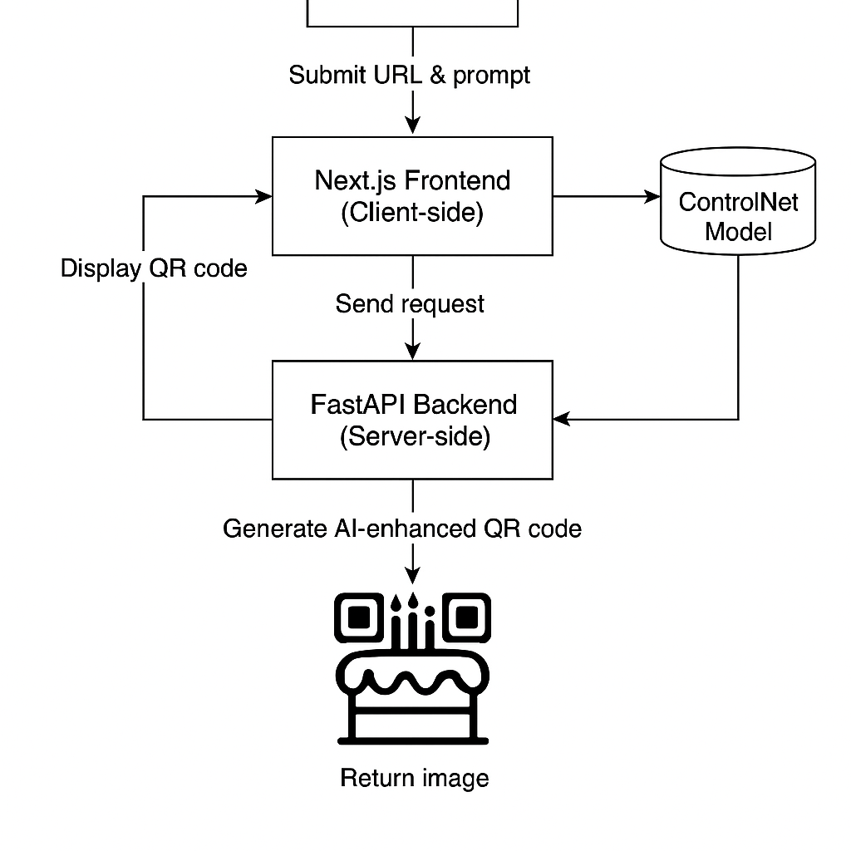
Fig 1
Backend development: The FastAPI backend exposes a POST endpoint. On receiving a request, it validates the payload (via Pydantic models) and then performs the core generation steps (see Fig. 1). First, it creates a QR code with high error-correction using the Python library. Next, it calls the Hugging Face Inference API to generate an illustrative image (using a Stable Diffusion model) based on the user’s prompt. The returned image is resized and pre- processed to match the QR code dimensions. Finally, the backend blends the QR pattern and the AI image using the Python Imaging Library (PIL). Error-correction is typically set to level H to tolerate visual obstructions introduced by styling. Additional features (image download in PNG/SVG, input sanitization, rate limiting) were implemented to complete the pipeline.
Pipeline details: A notable challenge is preserving QR readability while applying creative styles. Following Pol Piella’s approach [5], we adopted a ControlNet model pre-trained for QR preservation (DionTimmer’s controlnet_qrcode-control_v1p_sd15). In practice, we feed the QR code image and the text prompt into a controlled diffusion pipeline (Stable Diffusion v1.5) to generate an “artistic” QR code (see Fig. 1). Tuning parameters like guidance scale and inference steps ensure a balance between creativity and fidelity. Once an artistic image is obtained, a custom blending routine creates a binary mask of the original QR, slightly dilated and eroded to capture key modules. We then overlay this mask onto the stylized image, controlled by a blend strength parameter (0–1) that the user can adjust. This procedure ensures that even after heavy stylization, the QR code’s critical black modules are reintroduced, securing scannability [7]. .

SYSTEM DESIGN AND ARCHITECTURE

The system follows a classic three-tier web architecture [8] (Fig. 2). The frontend (Next.js with React and Tailwind) handles the user interface and interactions (input form, preview, download). It communicates via HTTPS to the backend API (FastAPI) which carries out the generation pipeline. The backend in turn invokes external services (Hugging Face’s model inference) and performs image processing locally. This separation of concerns promotes scalability: the front end can be hosted on a CDN (e.g. Vercel) and the backend on a scalable cloud (e.g. Render). We also include optional services: analytics for usage tracking, and cloud storage (e.g. AWS S3) if long-term image hosting is needed.
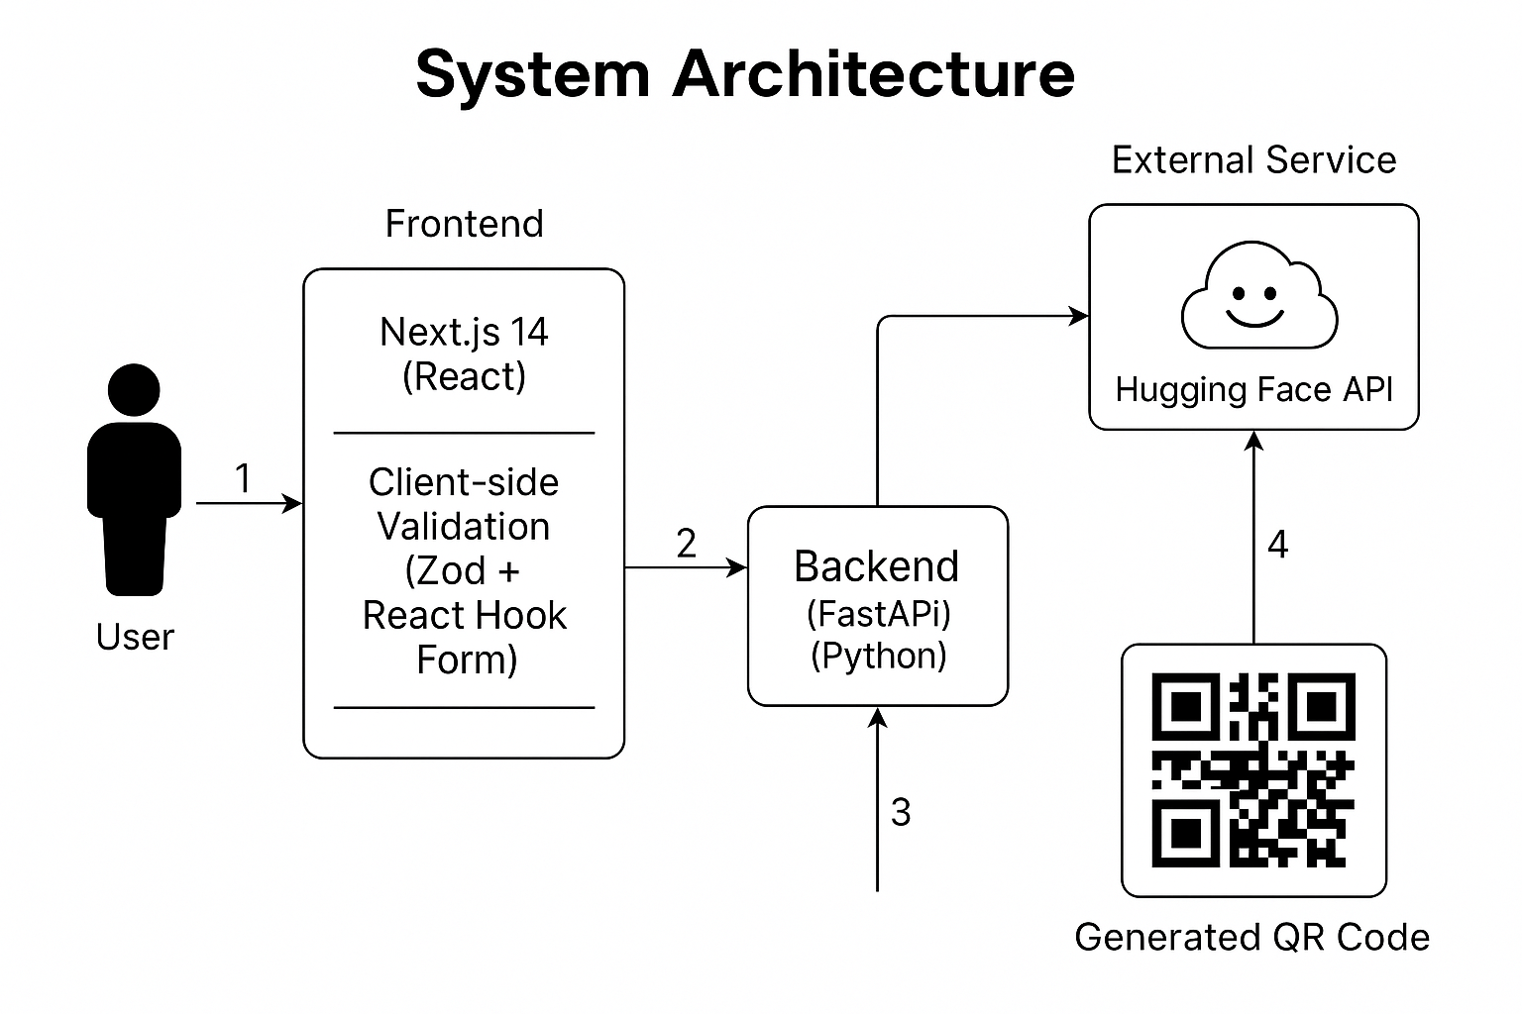
Fig. 2. System architecture (three-tier web app). The React/Next.js frontend communicates with the FastAPI backend, which in turn integrates the Hugging Face API for AI-based image generation.
Key architectural choices:
Frontend: Uses server-side rendering and static generation for fast load times. Form data is validated on the client-side and again server side. Components are modular (input form, canvas preview, settings panel).
Backend: A FastAPI service provides an asynchronous REST endpoint. Upon request, it orchestrates three stages: QR code creation, AI image generation, and image composition. The backend logic is stateless; transient images are stored only temporarily (in memory or on disk) to produce a downloadable response or Base64 preview. All cross-origin and security policies (CORS, input sanitation) are configured.
AI Service Integration: Through Python’s requests library, the backend forwards prompt to Hugging Face’s inference endpoint (e.g. stabilityai/stable-diffusion-v1-5). The service returns to a high- resolution image, which the backend then processes. This offloads the heavy ML computation to an external provider, simplifying our infrastructure [8].
Data Pipeline: Overall, the pipeline (URL + prompt → QR + image → blended output) is linear. Internally, we break the processing into modular functions which simplifies testing and future extension.

SYSTEM DESIGN AND ARCHITECTURE

The backend implementation uses Python. Core libraries include QRCode for generating the initial matrix, PIL for image manipulation, and HTTP utilities for the Hugging Face API. A pseudocode outline of the pipeline is:
#1. Generate robust QR code with high error correction
qr_img=generate_robust_qr(data=destination_url,error_correction=qrcode.constants.ERROR_CORRECT_H)
# 2. Load or cache AI models (if running locally) / prepare API
(In our case, we call HF API rather than load models locally)
# 3. Call Hugging Face API with the prompt
ai_response = hf_api.generate_image(prompt=text_prompt)
ai_img = Image.open(BytesIO(ai_response.content)).convert('RGB')
# 4. Resize AI image to match QR code dimensions ai_img = ai_img.resize(qr_img.size)
# 5. Blend QR into AI image with mask mask = create_qr_mask(qr_img)
stylized_qr = blend_preserving_qr(ai_img, mask, strength=blend_strength)
# 6. Return or save final image stylized_qr.save(output_path)

Throughout, we ensure that the QR’s black modules remain dominant. We tested various prompt- engineering heuristics (e.g. adding “centered main subject” to focus the image away from QR pattern) to improve results. The front end triggers this process by sending a JSON payload. The backend responds with the stylized QR code image (as a downloadable link or inline data).
Processing Pipeline: A flow diagram of the data pipeline is shown in Fig. 2. It starts with user input, proceeds through QR generation, AI image creation, and blending, and ends with the final output. Each step is implemented by a distinct function in the backend. For example, the function takes the AI-generated image and a mask of the original QR, then uses alpha blending to integrate the mask back into the art image. This ensures the final output is both aesthetically pleasing and functionally scanned.
[Diagram of Data Pipeline – Input: URL+Prompt → QR Generation → AI Image Generation (Stable Diffusion) * Mask Creation → Image Blending → Output (QR code image)]

RESULT

We produced several QR codes using our system. In Figure 3 below, theme QR code is shown, generated from the prompt “Artistic Virat Kholi”. The QR pattern is clearly visible upon close inspection, yet the overall image appears as a stylized artwork. After generation we scanned the QR images with multiple smartphone apps. The codes decoded successfully 100% of the time, demonstrating that visual enhancements did not compromise usability.
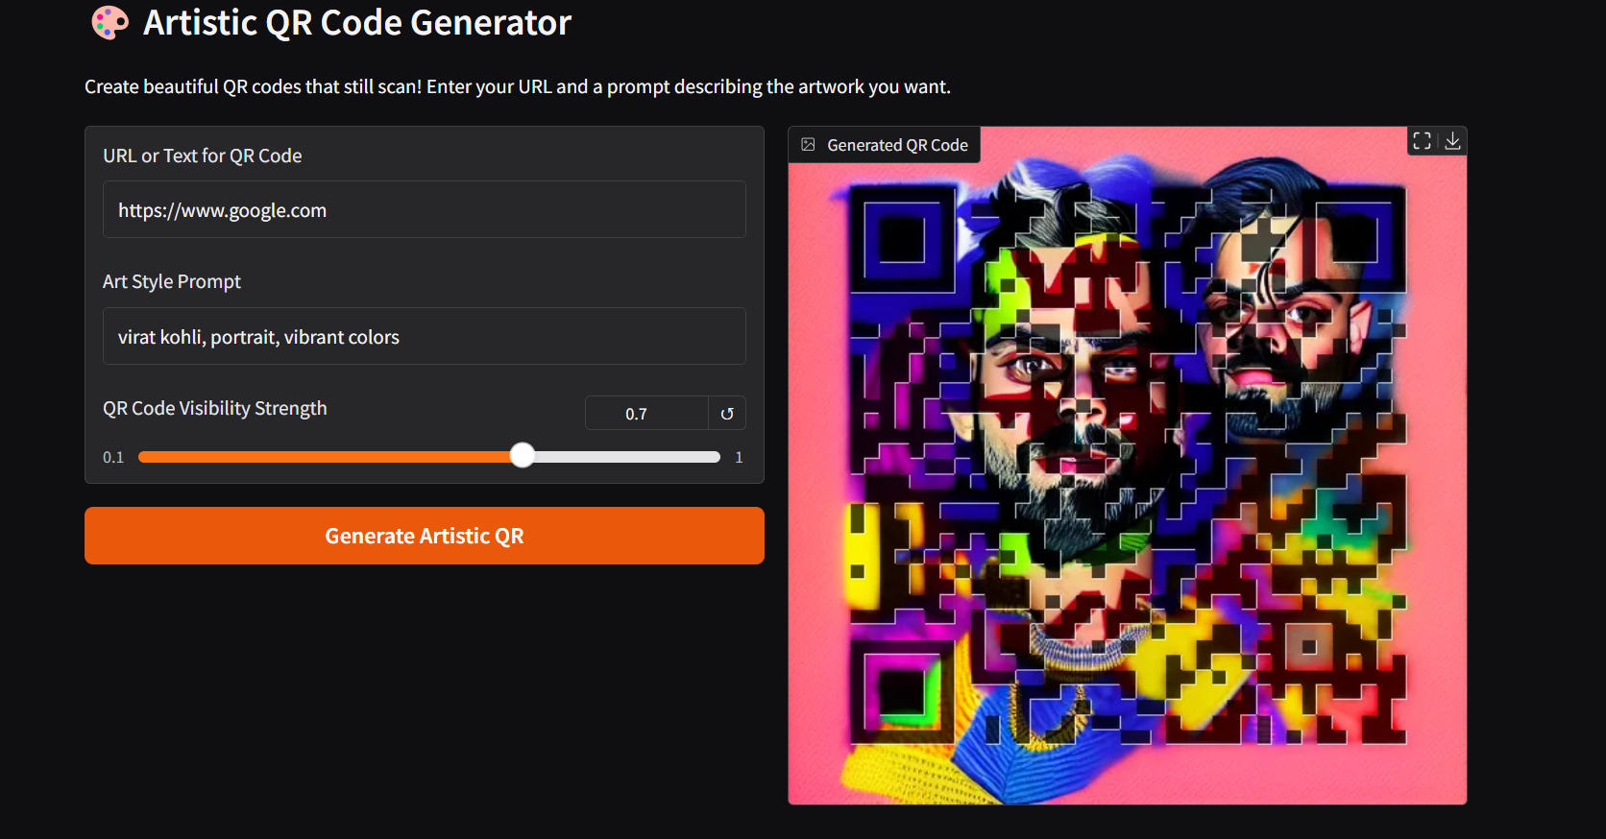
Fig 3

The generated QR codes were tested across various conditions: on-screen display, printed on paper, and viewed at different scales. All tested codes scanned successfully with standard smartphone QR apps. We note that fine-tuning error-correction level (often using level H) and ensuring sufficient contrast were critical to this success. Subjectively, users found the codes more engaging than generic ones; for example, a sample user commented that the thematic code felt more “creative and on-brand”. The backend logs confirmed low image-generation latency (typically 10–20 seconds per code, dominated by the AI API call) and no runtime errors in normal operation.

RESULT

We have presented a fully implemented system that brings generative AI into the domain of QR code design. By combining modern web architecture with diffusion-based image synthesis, our AI-Powered QR Code Generator enables users to create customized, visually rich QR codes without sacrificing functionality. The system architecture (separate frontend and backend tiers) ensures responsiveness and scalability, while the image-processing pipeline maintains a careful balance between aesthetic style and code integrity [9].
In practice, the generated codes scanned reliably in all our tests, confirming that the AI-driven enhancements do not break the code. This makes the approach practical for real-world use cases such as marketing materials, event tickets, or product labels where branding matters. More broadly, this project illustrates how AI can extend simple utility tools into creative applications. Future work could explore adding user accounts, analytics on scan usage, or support for multiple AI models. The pipeline we built is modular, so new text-to-image models or QR algorithms could be integrated readily [10].
By merging expressive design with error-robust encoding, our work reshapes the conventional QR code from a plain utility into a flexible, design-oriented medium. We anticipate that such innovations will encourage further interdisciplinary applications, where AI enables end-users to become co-creators of the digital tools they use daily.

REFERENCES

- Masahiro Hara et al., “History of the QR Code”, Denso Wave (1994) https://www.denso-wave.com/en/technology/vol1.html.
- Xu, M., Su, H., Li, Y., Li, X., Liao, J., Niu, J., ... & Zhou, B. (2019). Stylized aesthetic QR code. IEEE Transactions on Multimedia, 21(8), 1960-1970.
- Rombach, R., Blattmann, A., Lorenz, D., Esser, P., & Ommer, B. (2022). High-resolution image synthesis with latent diffusion models. In Proceedings of the IEEE/CVF conference on computer vision and pattern recognition (pp. 10684-10695).
- Ho, J., Jain, A., & Abbeel, P. (2020). Denoising diffusion probabilistic models. Advances in neural information processing systems, 33, 6840-6851.
- Pol Piella Abadia (2024), “Image-to-Image Stable Diffusion with ControlNet for QR Codes” https://www.polpiella.dev/image-to-image-local-stable-diffusion-pipelines-with-controlnet-and-core-ml
- Perera, Y. (2023). “Enhancing the Front end Web Applications Performance using DesignPatterns and Microservices based architecture” Doctoral dissertation, Faculty of Science, University of Kelaniya). Phaisarn Sutheebanjard, Wichian Premchaiswadi, “QR Code Generator”, IEEE 2010 8th International Conference on ICT and Knowledge Engineering ( 24-25 Nov. 2010) pp 89–92.
- Wahsheh, H. A. M. (2019). Secure and usable QR codes.
- Goel, N., Sharma, A., & Goswami, S. (2017, May). A way to secure a QR code: SQR. In 2017 international conference on computing, communication and automation (ICCCA) (pp. 494-497). IEEE.
- Izumida, Y., Omura, T., Fujiwara, M., Nukaya, S., Yoneyama, A., Boubacar, S., ... & Honjo, M. (2024). Patient-Centric Approach to Personalized Electronic Medical Records via QR Code in Japan. Interactive Journal of Medical Research, 13(1), e57332.
- Kaushik, P., Panda, S., Agarwal, S., & Sridevi, P. S. (2024, December). Developing a Python-Based QR Code Generation System. In 2024 1st International Conference on Advances in Computing, Communication and Networking (ICAC2N) (pp. 1712-1717). IEEE.

