**From Desert To Biomedical Research: Revisiting Camel-Derived Remedies For Sustainable Future**

**\*Dr. Roopam Bhardwaj, **Dr. Chandni Gupta, ***Prof. Navneet Sharma**

**\*PG scholar, **Associate Professor, ***Professor; R.G.G.P.G.Ayurvedic College and Hospital Paprola**

**Corresponding Author- *Dr. Roopam Bhardwaj**

**E Mail- roopambhardwaj47611@gmail.com**

**Phone No- 8219538251**

**Abstract**

**Aim:** To explore and compare the traditional Ayurvedic and modern scientific perspectives on the nutritional composition, therapeutic uses, and medicinal properties of camel milk and camel urine.

**Objective:** To critically analyse and integrate classical Ayurvedic knowledge and modern biomedical research on camel milk and urine, evaluating their roles in nutrition, traditional healing, and potential clinical applications.

**Materials and Methods:** A qualitative literature review was conducted using classical Ayurvedic texts (e.g., Charaka Samhita, Sushruta Samhita, Nighantus), ethnomedicinal sources, and peer-reviewed scientific studies. Data were compiled regarding the rasa (taste), guna (qualities), virya (potency), and karma (actions) of camel milk and urine, along with their biochemical composition, bioactive components, and reported health benefits.

**Results:** Camel milk is identified in both Ayurvedic and modern sources as having significant therapeutic value, particularly in managing Vata-Kapha disorders, diabetes, digestive issues, inflammation, and immune-related conditions. It contains bioactive compounds such as lactoferrin, lysozyme, insulin-like proteins, and antioxidant enzymes with antimicrobial, anti-diabetic, and anti-inflammatory properties. Camel urine, traditionally used in Middle Eastern and South Asian medicine, is described as having digestive, anti-inflammatory, and detoxifying effects. Its composition includes urea, creatinine, phenolic acids, and nanobodies with emerging scientific interest, although limited clinical validation exists.

**Conclusion:** Camel milk demonstrates strong potential as a functional food with established traditional use and growing scientific support. Camel urine, while historically important and biochemically interesting, requires rigorous scientific validation to confirm safety and efficacy. Bridging traditional knowledge with modern research can foster culturally respectful and evidence-based approaches to integrative medicine for sustainable future.

**Key Words-Camel milk, Camel urine, Sustainable future, Antidiabetic.**

1. **Introduction-**

In some of the world’s harshest and driest environments, one animal has quietly supported human survival for thousands of years—the camel. Often referred to as the "ship of the desert," camels are far more than just a mode of transport across sandy dunes. These remarkable creatures play a vital role in the lives of millions, particularly in arid and semi-arid regions across Africa, the Middle East, and Asia. From providing milk, meat, and wool, to serving as resilient pack animals, camels are a cornerstone of food security, economic stability, and cultural identity for many indigenous and rural communities. As climate change intensifies and sustainability becomes more urgent, the value of camels in adapting to extreme conditions is being recognized more than ever—making the 2024 International Year of Camelids a timely and important global initiative [1] by United Nation.Camel milk and camel urine have held significant roles in traditional medicine systems for centuries, particularly in regions such as the Middle East, North Africa, and South Asia [2],[3]. In Ayurveda, one of the world's oldest holistic healing systems, both substances are valued for their unique therapeutic properties. Camel milk is celebrated for its rich nutritional profile and potential in managing various health conditions, while camel urine, despite its controversial nature, has been used for its purported medicinal properties in traditional healing practices.In recent years, camel milk has attracted increasing interest in the field of modern medicine for its immunomodulatory, antimicrobial, and anti-diabetic potential. Conversely, camel urine remains largely confined to traditional medicinal contexts, with limited but emerging scientific evaluation. As the global health community continues to explore natural and alternative remedies, it is essential to revisit and critically assess these traditional practices through the lens of modern science.This review aims to explore and compare the nutritional composition, health benefits, and therapeutic uses of camel milk and camel urine. By examining both Ayurvedic and modern medical perspectives, the review seeks to bridge traditional knowledge with contemporary scientific research, highlighting areas of convergence and gaps in validation.

**Material and Methods-**

**Data Sources:** Literature was gathered from Ayurvedic texts, scientific journals, ethnomedicinal studies, and books on traditional healing practices. The review includes studies from both modern and Ayurvedic medical systems, focusing on camel milk and camel urine's health and medicinal properties.

**Camel Milk – Ayurvedic perspective**

**Table No. 1: Properties and Uses-**

|  |  |  |  |  |
| --- | --- | --- | --- | --- |
| **Text** | **Rasa (Taste)** | **Guna (Qualities)** | **Virya (Potency)** | **Karma (Actions / Benefits)** |
| **Charaka Samhita [4][5][6]** | Slightly salty, dry | Light | Hot | Cures Vata-Kapha disorders, bloating, inflammation, worms, piles, Given as Nasya in Trishna,  Internal and external application in Udara Roga |
| **Sushruta Samhita [7]** | Slightly salty, dry, pleasant | Light | Hot | Effective for digestive, skin, and toxic disorders; reduces inflammation |
| **Ashtanga Hridaya [8]** | Salty | Light, dry | Hot | Treats bloating, worms, piles, abdominal disorders |
| **Ashtanga Sangrah [9]** | Salty | Non-unctuous, easy to digest | Hot | Ideal for Vāta-Kapha diseases, parasites, edema, and piles |
| **Madanpal Nighantu [10]** | Sweet, rough, salty | Light | - | Improves digestion, laxative, treats worms, leprosy, kapha disorders, flatulence, inflammation, abdominal diseases |
| **Kaiyadeva Nighantu [11]** | Slightly bitter, alkaline, salty-sweet | Heavy, sharp, dry, clear | Hot | Treats cough, diabetes, colic, leprosy, jaundice, worms, piles, tumors, etc. |
| **Priya Nighantu [12]** | Salty-sweet, sour | Digestive | - | Used for weakness and leprosy (noted especially in Rajasthan) |
| **Dhanvantari Nighantu [13]** | Slightly salty, rough | Light | Hot | Useful in Vata-Kapha disorders, worms, indigestion, inflammation, piles |
| **Bhaishjya Ratnavali [14]** | - | - | - | Used as an Anupan of Kankayan gutika for Raktaj gulma Vikara. |

**Figure:1 Figure:2**

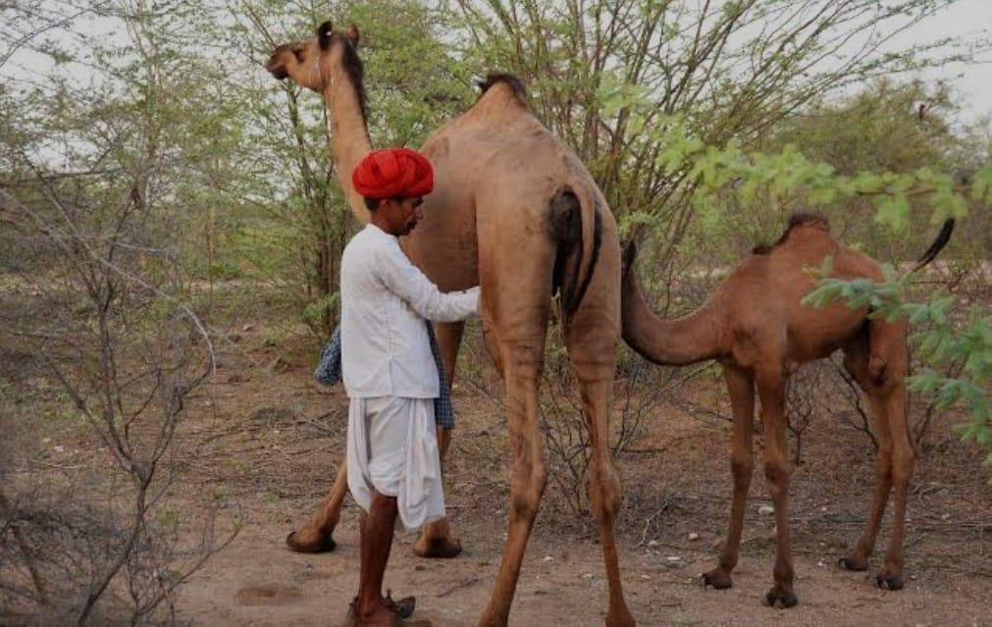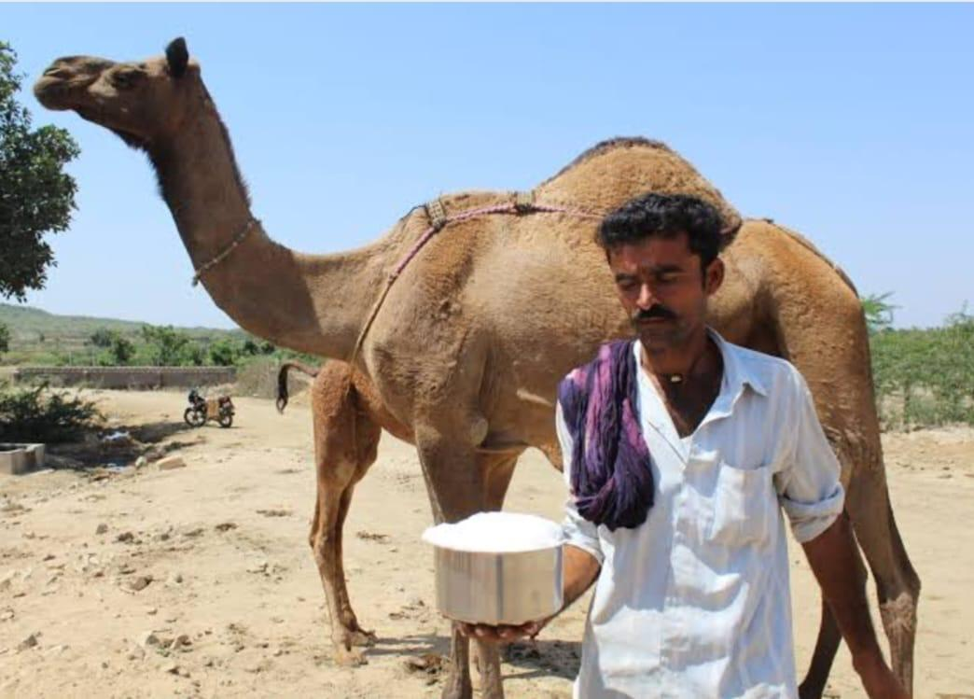

**Modern perspective-**

**Table No. 2**

**Composition and Nutritional Value [15]**

|  |  |
| --- | --- |
| Enzymes, Protective proteins and water | 74% |
| Fats | 5% |
| Proteins | 4% |
| Minerals | 1% |
| Vitamins & Electrolytes | 10% |
| Lactose | 6% |

**Table No. 3**

**Protein contents**

|  |  |
| --- | --- |
| Alpha 1 | 21% |
| Alpha 2 | 25% |
| Beta | 28% |
| k | 26% |

**Table No. 4**

**Fats**

|  |  |
| --- | --- |
| Pentadecenoic | 10% |
| Pentadecyclic | 14% |
| Myristdeic acid | 3% |
| Tridecoic acid | 3% |
| Lauric acid | 3% |
| Hendacanoic acid | 4% |
| Capric acid | 6% |
| Caprylic acid | 8% |
| Palmitdeic acid | 6% |
| Stearic acid | 6% |
| Mystric acid | 10% |
| Palmitic acid | 13% |
| Caporic acid | 12% |
| Butyric acid | 2% |

**Table No. 5**

**Minerals**

|  |  |
| --- | --- |
| Fe | 1% |
| Cu | 0% |
| Zn | 1% |
| Ca | 25% |
| Mg | 3% |
| P | 15% |
| Na | 17% |
| K | 38% |

**Table No. 6 Vitamins**

|  |  |
| --- | --- |
| Vitamin C | 4% |
| Niacin | 1% |
| Others Riboflavin, Thiamine, Folacin ,B6, B12, Pantothen |  |

# **Physical properties of camel milk**

**Table No. 7**

|  |  |  |  |  |
| --- | --- | --- | --- | --- |
| **Attribute** | **Minimum** | **Maximum** | **Mean** | **SE** |
| **Specific gravity** | 1.014 | 1.017 | 1.015 | 0.0006 |
| **pH Values** | 6.57 | 6.97 | 6.77 | 0.07 |
| **Acidity%** | 0.12 | 0.20 | 0.18 | 0.01 |

**Nutraceutical Properties of Camel Milk and Its Bioactive Components [15]**

**Table No. 8**

|  |  |  |
| --- | --- | --- |
| **Bioactive Component** | **Bioactivity** | **Key Findings** |
| **Lactoferrin** | Antimicrobial, Antioxidant, Anticancer, Anti-inflammatory | Potent against *E. coli*, *P. aeruginosa*, *S. aureus*; prevents DNA damage; inhibits cancer cell growth; reduces inflammatory cytokines |
| **Lysozyme** | Antimicrobial | Strong activity against *E. coli*, *S. aureus*, *L. monocytogenes* |
| **Lactoperoxidase** | Antimicrobial | Active against *E. coli*, *S. aureus*, *L. monocytogenes* |
| **Whey Protein Hydrolysates** | Antimicrobial, Antioxidant, Antidiabetic | Highly active after enzymatic hydrolysis; better than cow milk; improves insulin activity, inhibits glucosidase and amylase |
| **Whole Casein Hydrolysates** | Antimicrobial, Antioxidant, Antiradical, ACE-inhibitory | Effective against pathogens; strong antioxidant and radical scavenging; ACE-inhibitory peptides generated by proteinases |
| **Alpha Casein Hydrolysates** | Hypotensive | Fermentation with beneficial bacteria lowers blood pressure |
| **Beta Casein Hydrolysates** | Antihypertensive, Antioxidant, ACE-inhibitory, Antimicrobial | Enhances blood pressure control, antioxidant levels, ACE inhibition; shows antimicrobial properties post-fermentation |
| **Kappa Casein Hydrolysates** | Hypotensive, ACE-inhibitory | Fermented camel milk enhances hypotensive and ACE-inhibitory activity |
| **Alpha Lactalbumin** | Anticancer | Exosomes exhibit anti-breast cancer potential |
| **Insulin-like Proteins** | Antihepatitic, Antidiabetic | Prevents fatty liver; inhibits DPP-IV and alpha-amylase |
| **Whole Milk Hydrolysates** | Antioxidant, ACE-inhibitory, Antidiabetic, Antihypertensive, Anticancer, Antihepatitis, Anti-inflammatory | Fermented camel milk shows superior antioxidant, anticancer, antihypertensive, and anti-inflammatory effects |
| **Whole Proteins** | Anticancer, Antihypertensive, Hypocholesterolemic, Antidiabetic, Anti-inflammatory | Induces cancer cell apoptosis; lowers blood pressure; improves liver function; reduces inflammation; regulates blood glucose; aids in wound healing |

**Figure:3 [16]**

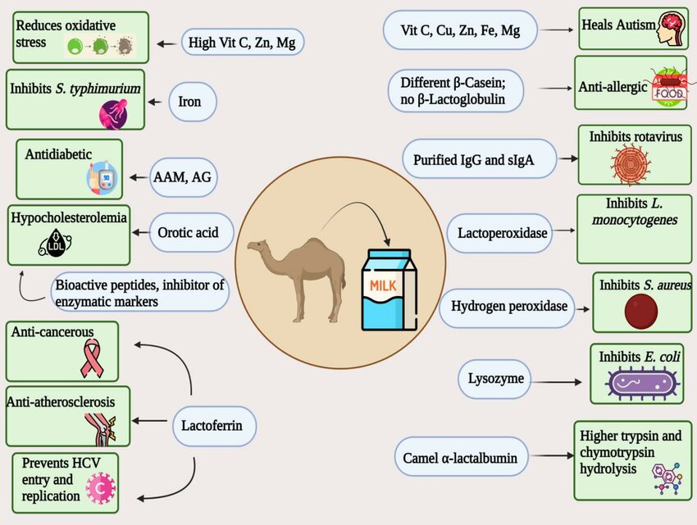

**Table No. 9 Therapeutic Effects and Context of Camel’s Milk**

|  |  |
| --- | --- |
| **Aspect** | **Details** |
| **Historical Use [17]** | Consumed for centuries in traditional medicine systems across the Middle East, North Africa, India, and Central Asia. Used by nomadic and pastoral communities for health and sustenance. |
| **Cultural Practice [18]** | Widely used in Middle Eastern, African, and South Asian traditional medicine. Often part of daily diet and traditional healing practices. |
| **Method of Use [19]** | Consumed fresh, fermented, or dried as powder. Sometimes combined with herbal preparations. Also used topically in some cultures. |
| **Health Conditions Treated [20]** | Used for diabetes, autism spectrum disorders, gastrointestinal issues, liver disease, food allergies, tuberculosis, malnutrition, and inflammatory conditions. |
| **Scientific Components [15]** | Rich in insulin-like proteins, immunoglobulins, lactoferrin, lysozyme, antioxidant enzymes, vitamins (B, C), and minerals (zinc, iron). Low in lactose and free of β-lactoglobulin. |
| **Medical Potential [21]** | Potential anti-diabetic, antioxidant, antimicrobial, and immunomodulatory effects. Promising in managing autoimmune and metabolic disorders. |
| **Key Researchers / Studies** | Studies by Agrawal (2005–2014), Al-Numair (2011), Korashy (2012), Redwan and Tabll (2007), among others. |
| **Modern Countries of Use [22]** | Consumed in UAE, Saudi Arabia, India, Kenya, USA, Australia, and various European countries as a functional food and dietary supplement. |
| **Concerns / Risks [23]** | Limited availability; high cost; need for standardized processing and storage; insufficient large-scale clinical trials; potential allergenicity in rare cases. |
| **Ethical / Cultural Sensitivity [24]** | Highly valued in many cultures; often considered sacred or medicinal. Promoting it requires respect for traditional knowledge and sensitivity to cultural beliefs. |
| **\*Community Health Boost** | Camel milk, sold by India's largest dairy cooperative Amul, contains insulin-like proteins that may help lower blood sugar levels and improve insulin sensitivity in diabetics. (Figure:4) |

**Figure:4[25]**

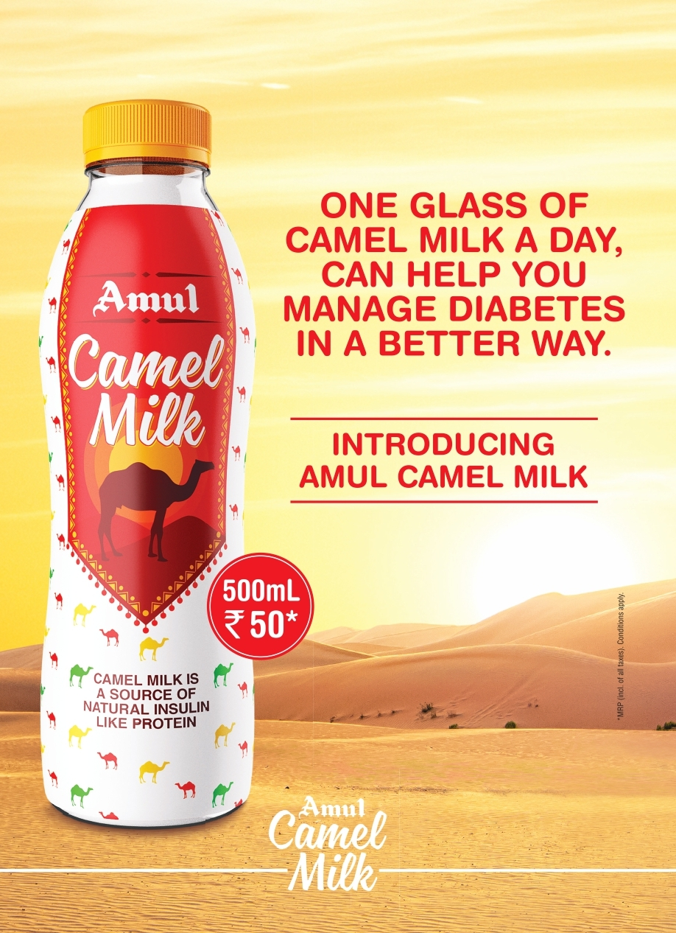

**Camel Urine**

**Ayurvedic perspective-**

**Table No. 10. Properties and Uses-**

|  |  |  |  |  |
| --- | --- | --- | --- | --- |
| **Text** | **Rasa (Taste)** | **Guna (Qualities)** | **Virya (Potency)** | **Karma (Actions / Benefits)** |
| **Charaka Samhita [26]** | Slightly bitter | - | - | Helps with asthma, cough, hemorrhoids |
| **Sushruta Samhita [27]** | - | Penetrating, easily digestible | Hot | Reduces swelling, acts as antidote, treats piles, worms, urinary issues |
| **Ashtanga Hridaya [28]** | Pungent, salty (aftertaste) | Sharp, dry, light | Hot | Cures worms, abdominal issues, pain, anemia, poisoning, skin disorders |
| **Ashtanga Sangrah [29]** | Pungent, salty (aftertaste) | Non-unctuous, penetrating | Hot | Breaks toxins, cures worms, tumors, skin diseases, piles; used in enemas, fomentation, etc. |
| **Madanpal Nighantu [30]** | - | - | - | Treats madness, piles, worms, swelling, colic, abdominal diseases |
| **Kaiyadeva Nighantu [31]** | Bitter, pungent | Digestive | Hot | Good for abdominal disorders, swelling, madness, worms, leprosy |
| **Dhanvantari Nighantu [32 ]** | - | - | Hot | Destroys swelling, leprosy, abdominal diseases, mental disorders |

**Modern perspective-**

**Table No. 11. Properties and composition [33]**

|  |  |  |
| --- | --- | --- |
| **Component** | **Description/Properties** | **Significance/Function** |
| General Composition | Sterile, transparent, slightly yellowish liquid | Water-soluble substances easily excreted by the body. Contains urea, creatinine, ammonia, organic acids, amino acids. |
| Urea | A nitrogenous waste product, present in high concentrations (18–36 mg/dl) | Contributes to toxicity and odor of camel urine; part of nitrogen waste. |
| Creatinine | Byproduct of muscle metabolism | Used to assess kidney function; contributes to the chemical makeup of urine. |
| Ammonia | Present in small traces along with urea | Contributes to the strong smell of camel urine; may have some antimicrobial properties. |
| Chlorides | Mineral salts found in camel urine | Electrolyte balance and osmotic regulation in the body. |
| Hippuric Acid | Organic acid found in camel urine | Metabolite involved in detoxification and potentially antimicrobial. |
| Benzoic Acid | Major bioactive acid in camel urine | Known for antimicrobial and antioxidant effects. |
| Citric Acid | Organic acid found in urine | Plays a role in acid-base balance and may have antioxidant properties. |
| Phenylacetate | Organic acid detected in camel urine | Associated with anti-inflammatory and antioxidant effects. |
| Salicylic Acid | Bioactive acid found in camel urine | Known for its anti-inflammatory properties, similar to aspirin. |
| pH | Weakly to strongly alkaline (varies by age and diet) | Contributes to the alkaline nature of camel urine, potentially affecting its use in treatments. |
| Density | Ranges from 1.01 to 1.07 in older camels (5–10 years) | Indicates the concentration of urine, affecting its potential medicinal properties. |
| Calcium Oxalate Crystals | Present in urine upon microscopic examination | Can contribute to kidney stone formation, but may also have antimicrobial properties. |
| Phosphorus | Present in camel urine | Aids in bone health, metabolism, and electrolyte balance. |
| Ammonium Urate | Crystals detected in urine through microscopy | May play a role in metabolic waste removal and detoxification. |
| Keratin | Present in small quantities (0.2 to 0.5 mg/l) | Protein-like substance that may have a role in skin or tissue regeneration. |
| Minerals (Sodium, Zinc, Potassium) | Present in considerable levels (via neutron activation analysis) | Key for electrolyte balance and essential body functions; may help treat diarrhea or electrolyte imbalance. |
| Fatty Acids and Amino Acids | Includes canavanine, prostaglandins, among others (found through GC-MS and ICP-MS) | Bioactive metabolites with potential anti-inflammatory, antioxidant, and immune-boosting effects. |
| Metabolites (30 compounds) | Detected using GC-MS and LC-MS analysis (e.g., fatty acids, amino acids, sugars, benzene propanoic acid) | Higher metabolite concentration compared to other livestock; contributes to the potential medicinal benefits of camel urine. |
| Toxicity and Odor | Camel urine has a strong ammonia and urea odor | Contributes to its toxicity; requires proper processing for medicinal use. |
| Electrolyte Balance | High levels of sodium, potassium, and zinc found in urine | Can neutralize electrolyte imbalance due to diarrhoea or dehydration (therapeutic use). |
| Microscopic Findings | Presence of epithelial and granular cells, calcium oxalate, phosphorus, and ammonium urate crystals | Key indicators for potential kidney function and overall metabolic health in camels. |

This table summarizes the key components of camel urine, their properties, and their significance for both traditional and potential modern medicinal uses. It highlights how camel urine's chemical profile makes it a potentially valuable substance in various treatments, particularly those focused on electrolyte balance, anti-inflammatory, antimicrobial, and detoxification properties. However, further research is needed to confirm its medical efficacy and safety in humans.

**Table No.12. Therapeutic Effects and Context of Camel’s Urine**

|  |  |
| --- | --- |
| **Aspect** | **Details** |
| **Historical Use [34]** | Part of *Prophetic Medicine* and pre-Islamic traditional healing. Used for centuries in the **Arabian Peninsula** and other regions. |
| **Cultural Practice [35]** | Widely used in **Middle Eastern, Indian, Chinese, and African** alternative medicine systems. |
| **Method of Use [36]** | Consumed **orally**, either directly or mixed with **camel milk**. Sometimes used concurrently with **conventional medicine**. |
| **Health Conditions Treated [37]** | Used for **fevers, colds, tumors, tuberculosis, leprosy, hemorrhoids, colic, anemia, abdominal tumors**, and more. |
| **Scientific Components [38]** | Contains **nano-sized antibodies** (heavy-chain antibodies, aka *nanobodies*), which can cross the **blood–brain barrier** and intestinal lining. |
| **Medical Potential [39]** | Nanobodies used in **biosensor development**, **cancer diagnostics and treatment**, and possibly **immune system modulation**. |
| **Key Researchers / Studies** | Studies by **Khorshid (2009), Alhaidar et al. (2011, 2012, 2013), Abdel Gader and Alhaider (2016)**, among others. |
| **Modern Countries of Use [40]** | Besides Middle East, reportedly used in **India, China, Mongolia**, and even **UK, USA, Europe**. |
| **Concerns / Risks [41]** | Use without **medical supervision**; potential **drug interactions**; **insufficient clinical trials** to confirm efficacy and safety. |
| **Ethical / Cultural Sensitivity [42]** | Practice is tied to **religious and cultural beliefs**; requires **respectful discourse** in scientific and healthcare discussions. |

**Figure:5[43]**

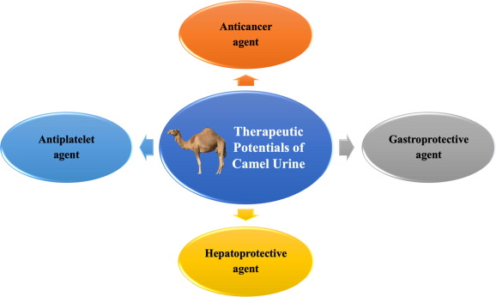

**Safety and Ethical Concerns-**

The use of camel urine as a therapeutic agent, while rooted in traditional systems like Prophetic medicine and occasionally explored in alternative health practices, presents significant safety, ethical, and regulatory concerns in the context of modern medicine. Scepticism arises primarily from the lack of robust clinical evidence [44], potential biological risks [45] such as contamination and zoonotic contaminations (e.g., MERS-CoV), and widespread cultural aversion to urine consumption. Regulatory bodies like the WHO [46], FDA, and EMA do not recognize camel urine as a validated medical treatment, emphasizing the need for severe scientific testing. Safety depends heavily on the health of the camel, hygienic collection methods, and controlled dosage—factors often unnoticed in informal or traditional use. From an Ayurvedic viewpoint [35], although camel urine is not clearly referenced, its integration would require adherence to foundational concepts like Anupana (vehicle for administration) and Samskara (processing or purification) to ensure safety and efficacy. Therefore, any exploration of camel urine in therapeutic contexts must be approached with caution, stringent regulation, and cultural sensitivity.

**Result-**

The consolidative review of classical Ayurvedic texts and modern biomedical literature discloses a convergence in the acknowledgement of camel milk’s nutritional and therapeutic value. Ayurvedic sources constantly describe camel milk as light, hot in potency, and effective in managing Vāta-Kapha disorders, digestive disturbances, inflammation, skin conditions, and parasitic infestations. Likewise, modern studies highlight camel milk's bioactive components—such as **lactoferrin, lysozyme, insulin-like proteins, and antioxidant enzymes**—which determine **antimicrobial, anti-inflammatory, antidiabetic, and immunomodulatory effects**. Nutritionally, camel milk is rich in essential vitamins (especially C and B-complex), minerals (calcium, potassium, phosphorus), and protective proteins while being low in allergens like β-lactoglobulin. Camel urine, though less explored systematically, is historically used in Middle Eastern, African, and South Asian healing systems. Ayurvedic texts associate it with **hot potency**, **digestive and detoxifying actions**, and usefulness against **swelling, worms, piles, skin diseases, and mental disorders**. Scientific studies indicate it comprises **urea, creatinine, phenolic acids, nanobodies, fatty acids**, and **antioxidant compounds** such as **salicylic and benzoic acid**, with reported **antimicrobial, anti-inflammatory, and immune-modulating potential**. However, the **clinical validation of camel urine is limited**, and concerns remain concerning **toxicity, contamination, cultural acceptability**, and **regulatory approval**.

**Conclusion-**

Camel milk stands out as a nutritionally rich and therapeutically effective substance supported by both Ayurvedic knowledge and modern scientific research. Its effectiveness in managing metabolic, autoimmune, and inflammatory conditions positions it as a capable **functional food** in integrative health models. In contrast, camel urine, while historically and traditionally significant, especially in Prophetic and traditional Asian medicine, lacks robust clinical evidence to authenticate its therapeutic claims. Safety concerns, ethical contemplations, and the absence of regulatory recognition require **cautious exploration and rigorous scientific scrutiny**. Connecting traditional Ayurvedic knowledge with contemporary research offers a path toward **evidence-based and culturally respectful integrative medicine for sustainable future**. Camel milk, with its multifaceted health benefits, is ready for wide-ranging clinical application, whereas camel urine remains a **potential but unverified remedy** necessitating further investigation under controlled, ethical, and scientifically validated situations.

**References-**

1. Food and Agriculture Organization of the United Nations (FAO). International Year of Camelids (IYC) 2024 [Internet]. FAO; [cited 2025 May 6].

2. Singh R, Mal G, Kumar D, Patil NV, Pathak KML. Camel Milk: An Important Natural Adjuvant. Agric Res. 2017;6(4):383–91.

3.Camel urine [Internet]. Wikipedia; [cited 2025 May 6].

4.Pandit Kaashinath Shastri, Dr.Gorakhnath Chaturvedi, Charak Samhita, Chowkhambha Bharti Academy;Varanasi Sutra sthana 27/220p-551

5.Pandit Kaashinath Shastri, Dr.Gorakhnath Chaturvedi, Charak Samhita, Chowkhambha Bharti Academy;Varanasi Chikitsa sthana 12/26p-360

6.Pandit Kaashinath Shastri, Dr.Gorakhnath Chaturvedi, Charak Samhita, Chowkhambha Bharti Academy;Varanasi , Chikitsa sthana 22/33p-618

7. Kaviraj Dr. Ambikaduttshashtri,A.M.S.,Sushrut Samhita,Chowkhambha Sanskrit Sansthan; Varanasi;2017, Sutra sthana.45/53p-223.

8. Dr. Shailja Srivastava, Chowkhambha Orientalia; Varanasi;2009, Sutra sthan 5/25, p-80

9. Prof. K.R.Srikanth Murthy, Chaukhambha Orientalia; Varanasi; 2005, Sutra sthana 6/55, p-95

10. Nripmadanpal. Madanpal Nighantu. Varanasi: Chowkhamba Krishnadas Academy, 2009, Paaniyadi varga Verse.71 p-198

11. Sharma P, editor and commentator. Kaidev Nighantu. Varanasi: Chowkhamba Orientalia; 2006 DugdhaVarga Verse.143-145p-345.

12. Sharma PV. Priya Nighantu. Varanasi: Chowkhamba Surbharati Prakashan, Drava Varga , Verse.16p-229.

13 Prof. Priya Vrat Sharma,Dr. Guru Prasad Sharma, Dhanvantari Nighantu,Varanasi: Chowkhamba Orientalia 2008; Suvaranaadi vargaVerse.453 p258.

14. Bhaishajya Ratnavali Gulmarogadhikara 32/68-74

15.Al-Juboori A, Abbas R, Salih K, Al-Shuhaib M. An updated comprehensive review of camel milk: Composition, therapeutic properties, and industrial applications.

16.<https://www.researchgate.net/publication/370060730/figure/fig1/AS:11431281158098436@1684029692831/Camel-milk-has-significant-dietary-medicinal-and-nutritional-ramifications-for-humans.jpg>

17.Food and Agriculture Organization of the United Nations (FAO). Camel milk and its utilization [Internet]. Rome: FAO; 2006 [cited 2025 May 6].

18.Seifu E. Chemical composition and microbiological quality of camel milk in eastern Ethiopia. *Livest Res Rural Dev*. 2007;19(6).

19.Seifu E, Tafesse B. Functional properties and potential health benefits of camel milk and its products: A review. Food Prod Process Nutr. 2023;5(1):30.

20. Mihic T, Rainkie D, Wilby KJ, Pawluk SA. The therapeutic effects of camel milk: A systematic review of animal and human trials. SAGE Open Med. 2016;4:2156587216658846.

21.Behrouz B, Saadat MA, Memarzia MA, Sarir M, Folkerts T, Boskabady M. The antioxidant, anti-inflammatory and immunomodulatory effects of camel milk. Front Immunol. 2022; 13:855342.

22.Battikh H, Al-Busaidi A, Rzaigui A, Msaddak L. Consumer acceptance and preference for camel milk in selected European and Mediterranean countries. Sustainability. 2022;14(22):15424.

23. Zeleke T, Seifu E. Camel milk products: Innovations, limitations, and opportunities. Food Prod Process Nutr. 2023;5(1):30.

24. CamelAdvisor. Camel milk: Significance in camel domestication [Internet]. [cited 2025 May 6].

25. <https://www.amul.com/files/products/promotion/Camel_Milk_Leaflet_page-0001.jpg>

26. Pandit Kaashinath Shastri, Dr.Gorakhnath Chaturvedi, Charak Samhita, Chowkhambha Bharti Academy;Varanasi Sutra sthana 1/105p-45

27. Kaviraj Dr. Ambikaduttshashtri,A.M.S.,Sushrut Samhita,Chowkhambha Sanskrit Sansthan; Varanasi;2017, Sutra sthana 46/228 p-241.

28. Dr. Shailja Srivastava, Chowkhambha Orientalia; Varanasi;2009, Sutra sthan 5/82-83p-93

29.Prof. K.R.Srikanth Murthy, Chaukhambha Orientalia; Varanasi; 2005, Sutra sthana 6/136-137, p-113

30. Nripmadanpal. Madanpal Nighantu. Varanasi: Chowkhamba Krishnadas Academy, 2009, Paaniyadi varga Verse.215p-222

31. Sharma P, editor and commentator. Kaidev Nighantu. Varanasi: Chowkhamba Orientalia;2006, Mutra varga Verse.446 p-400

32. Prof. Priya Vrat Sharma,Dr. Guru Prasad Sharma, Dhanvantari Nighantu,Varanasi: Chowkhamba Orientalia 2008; Suvaranaadi vargaVerse.158 p-207.

33. Alqahtani S, Alshahrani S, Alsharif F. Camel urine characteristics and its bioactive molecules on potential impacts against diseases and pathogenic microorganisms. Indian J Anim Res. 2020;54(12):1477–82.

34. Al-Eisa Y. Traditional uses and therapeutic potential of camel urine in Middle Eastern cultures [Internet]. ResearchGate; [cited 2025 May 6].

35. Khalil A, Obeidat B. Cultural significance and uses of camel milk and urine in traditional medicine [Internet]. PubMed; [cited 2025 May 6].

36. Ahmad A. Health benefits of camel milk and urine in alternative medicine: A review [Internet]. SpringerLink; [cited 2025 May 6].

37.Yusuf M, Khan Z. Medicinal benefits of camel milk and urine for treating human health disorders [Internet]. ScienceDirect; [cited 2025 May 6].

38. Muyldermans S. Camel antibodies: Novel biotechnological tools [Internet]. NCBI; [cited 2025 May 6].

39. Salah S, Hassen R. The potential role of camel nanobodies in therapeutics and diagnostics. J Transl Med. [cited 2025 May 6].

40. Al-Hadithi L, Jones P. Camel urine use in modern medicine: A global perspective. MDPI. [cited 2025 May 6].

41.Al-Ramahi R. Challenges in the use of camel milk and urine for medical purposes [Internet]. PubMed; [cited 2025 May 6].

42. Smith H. Ethical and cultural sensitivity in the promotion of traditional medicine: A case study of camel milk and urine [Internet]. SpringerLink; [cited 2025 May 6].

43. <https://ars.els-cdn.com/content/image/1-s2.0-S1319016421001031-gr2.jpg>

44. WHO EMRO. Use of camel urine is of no benefit to cancer patients: Observational study and literature review [Internet]. EMRO WHO; [cited 2025 May 6].

45. US News. Stop drinking camel urine, World Health Organization says [Internet]. [cited 2025 May 6].

46. US News. Stop drinking camel urine, World Health Organization says [Internet]. [cited 2025 May 6].