VIRTUAL REALITY IN MENTAL HEALTH

**Nurul Nisha, Nazia Ali**

***Nurul Nisha.*** *Occupational Therapist, CBM India Trust, Dakshinpuri Branch, New Delhi-110062*

***Nazia Ali*.*** *Assistant Professor, Department of Occupational Therapy, SNSAH, Jamia Hamdard, New Delhi-110062*

OVERVIEW

Introduction Principles

Types Role of OT in VR

Applications Uses of VR Advantages and Disadvantages Challenges Conclusion

## INTRODUCTION

Virtual reality (VR) is a computer-generated three-dimensional (3D) simulation, such as a set of images and sounds of real-life situations, with which one can interact in a seemingly realistic way by using special electronic equipment. The current standard VR systems use VR headsets with head-mounted display. Virtual reality provides not only visual and auditory stimuli but also tactile and olfactory stimuli. The subjective feeling that a user experiences in VR as “being there” is termed presence.

## VIRTUAL REALTY IN MENTAL HEALTH

Virtual reality is used in mental health to create immersive simulations that allow patients to confront their fears and anxieties in a safe and controlled environment. It can be used to treat a variety of mental health conditions, including anxiety disorders, PTSD, depression, and eating disorders.

## KEY PRINCIPLES

There are different principles that are applicable to virtual reality therapy:

1. Creating a safe and controlled environment of “being there” or being present in the virtual environment.
2. Providing real-time feedback to patients and therapists on progress and treatment effectiveness.
3. Tailoring the virtual environment to the individual needs and goals of each patient.

**Mix Reality**

* Mixed Reality (MR) is a hybrid technology that emerges real and virtual environments, allowing physical and digital objects to interact in real time. MR is emerging as a transformative tool in mental health care. A recent research paper explores the significant potential of MR technology as an enabler of the metaverse, specifically aimed at enhancing mental health therapies. The study suggests that the interactive and immersive benefits of MR, combined with the adaptive capabilities of a multiuser, three-dimensional digital space, promise a paradigm shift in mental health support delivery.

1. Allowing patients to interact with the virtual environment in a meaningful way.
2. Gradually expose patients to their fears and triggers.

**TYPES OF VIRTUAL REALITY**

**Non-Immersive Virtual Reality**

* Non-immersive VR, often referred to as desktop VR, employs standard computer monitors, speakers, and input devices like mice to display and interact with virtual environments. While this setup offers a lower level of immersion, it remains a practical and accessible tool for health and safety training in high-risk engineering sectors. Despite lacking the deep sense of presence found in more immersive systems, non-immersive VR provides valuable interactive experiences that can effectively convey complex concepts and procedures.

**Immersive Virtual Reality**

* Immersion into virtual reality is a perception of being physically present in a non-physical world.
* Elements of virtual environments that increase the immersiveness of the experience:
* Continuity of surroundings
* Conformance to human vision
* Freedom of movement
* Physical interaction
* Physical feedback

**Semi- Immersive Virtual Reality**

* Semi-immersive virtual reality (VR) systems, such as the Cave Automatic Virtual Environment (CAVE), utilize multiple projectors and screens to create a 3D virtual space, offering users a heightened sense of presence compared to non-immersive setups. These systems have been effectively employed in health and safety training across various high-risk engineering industries, providing immersive simulations that enhance learning outcomes. However, the complexity and high costs associated with constructing and maintaining CAVE facilities have limited their widespread adoption.

**Augmented Reality**

* Augmented Reality (AR) is a technology that overlays digital content onto the real world, enhancing user perception without fully immersing them in a virtual environment. AR has been increasingly utilized in mental health interventions to provide immersive and interactive therapeutic experiences. A recent study introduced an innovative AR exposure therapy designed to address limitations of traditional interventions for anxiety disorders and PTSD by directly targeting social and occupational dysfunction through exposure to real-life social contexts.

**Other types of Virtual Reality**

* Web-Based Virtual Reality

(WebVR)

* Enables VR experiences directly through web browsers without requiring high-end VR hard.
* Collaborative Virtual Reality (Social VR)
* Allows multiple users to interact in a shared virtual environment for remote meetings, education, and social networking.
* Cyberspace VR (Networked VR)
* A networked virtual environment where users interact with AI, real users, and objects across different locations.
* Haptic VR (Tactile VR)
* Integrates haptic feedback (touch sensations) to enhance realism.

# ROLE OF OT IN VIRTUAL REALITY

The use of VR technologies is a new and promising mode of treatment shown to improve outcomes compared to traditional approaches used in rehabilitation. Not only is it a tool for facilitation of practice, but it has become an integral part of our contexts without which interaction in our current environment is hindered. It can be utilized over a variety of diagnoses and implemented across the lifespan to simulate, immerse, expose, and encourage virtually any desired result at a relatively cost-effective price. Occupational therapy practitioners should assess the feasibility of the integration of this technology into respective practices and the technical development of these tools to ensure the application elicits the desired outcomes for the client while increasing compliance and reducing monotony sometimes associated with conventional rehabilitation interventions.

Technology is a common element in our everyday lives, as almost every aspect of our existence has been transformed by smartphones, Alexas, wifi, and/or Bluetooth. According to the Occupational Therapy Practice Framework Fourth Edition (OTPF-4), virtual interventions are part of the occupational therapy process and include simulated technology for service delivery with the absence of physical contact (American Occupational Therapy Association [AOTA], 2020).

Technology is no longer only a means for facilitating occupation; it is also the target of our occupation. The OTPF-4 also identifies technology as an environmental factor, meaning managing human-made technology as an aspect of our physical and social environment, so we must learn to navigate this area to optimize the client’s occupational performance (AOTA, 2020). As our daily use of technology continues to evolve, computer-generated and virtual reality (VR) based interventions will become a more prevalent feature of occupational therapy (OT) practice.

# APPLICATION OF VIRTUAL REALITY

Application of Virtual Reality in Mental Health (As shown in FIG 1.0):

### Clinical Settings

* VR is used in exposure therapy to help patients with anxiety disorders, phobias, and PTSD by simulating controlled environments.
* It provides immersive scenarios to practice coping strategies and emotional regulation.

### Rehabilitation Settings

* VR is utilized for cognitive and motor rehabilitation in conditions like stroke and traumatic brain injury.
* It helps with social skill training for individuals with autism spectrum disorder (ASD) and schizophrenia.
* Occupational therapists use VR to enhance engagement in meaningful activities.

### Education and Training Settings

* VR-based simulations train mental health professionals and caregivers in handling psychiatric emergencies.
* Patients can practice real-life scenarios, such as job interviews or social interactions, in a safe environment.

### Personal Growth and Wellness

* VR is used for mindfulness, meditation, and stress reduction, helping individuals with anxiety and depression.
* Guided VR interventions improve emotional resilience and coping mechanisms.

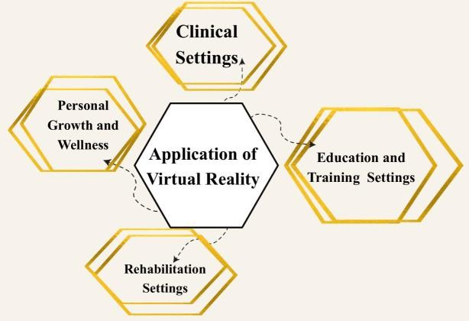

FIG 1.0

# USES OF VIRTAL REALITY

## ASSESSMENT

The assessment of mental health conditions using Virtual Reality (VR) is an emerging field that allows for real-time evaluation of behavioral, emotional, cognitive, and physiological responses. The therapist will conduct an assessment of the patient’s mental health condition and determine if virtual reality is an appropriate treatment option.

VR has also been applied to assess cognitive and social deficits in Psychosis, providing a structured means to evaluate executive function and social cognition.

## PREPRATION

The therapist will explain the virtual reality therapy process to the patient and provide instructions on how to use the equipment.

## THERAPY SESSIONS

Therapy Sessions can be taken by creating immersive, controlled environments to help clients practice coping strategies, improve emotional regulation, and reduce anxiety. VR exposure therapy can simulate real-life scenarios for phobia treatment, PTSD desensitization, and social skills training, making interventions more engaging and effective. Additionally, interactive VR exercises can enhance mindfulness, relaxation, and cognitive rehabilitation in a safe, adaptable setting.

## FEEDBACK & ADJUSTMENTS

The therapist will explain the virtual reality therapy process to the patient and provide instructions on how to use the equipment.

## FOLLOW UP

The therapist will schedule follow-up appointments to monitor the patient’s progress and adjust the therapy as necessary.

**ADVANTAGES AND DISADVANTAGES**

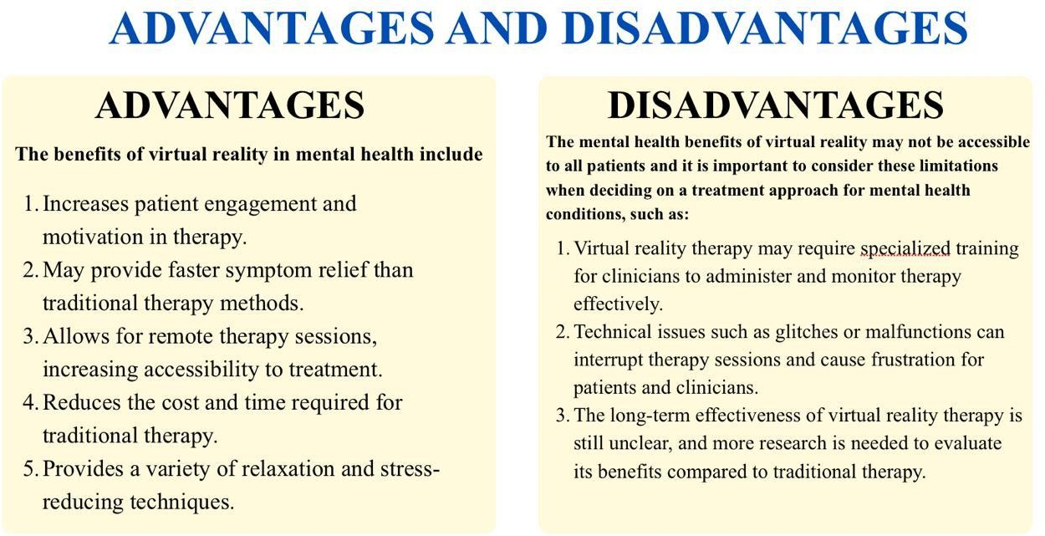

# CHALLENGES

Virtual Reality (VR) in mental health faces several challenges. The **high cost** of VR hardware and software limits accessibility, while **motion sickness** can hinder user experience. **Technological constraints**, such as limited processing power and the need for high-speed internet, affect seamless application. Additionally, diverse therapeutic needs make it difficult to create universally effective VR programs. Lastly, **data privacy** and **security concerns** pose risks, as sensitive patient information may be vulnerable to breaches in virtual environments.

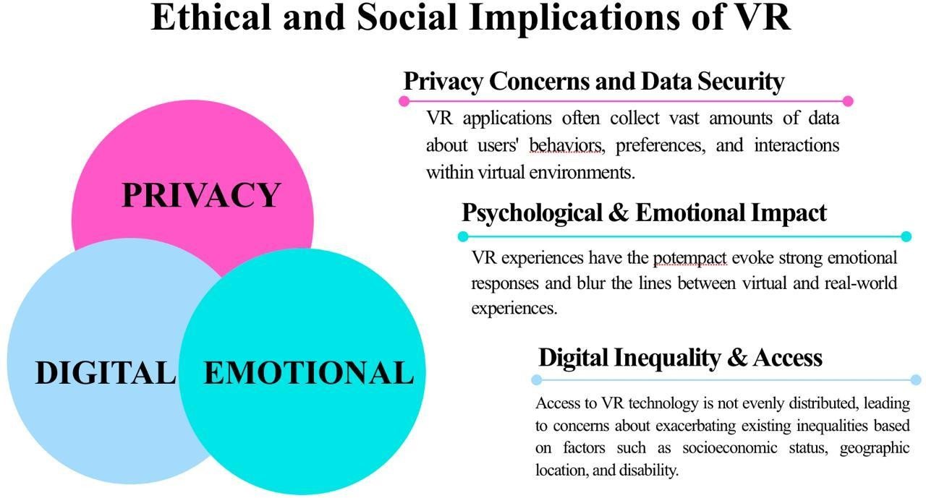

## CONCLUSION

Virtual reality is turning out to be a useful tool for treating mental health conditions. For people with any mental health condition, this technology allows therapists to create rich, immersive experiences that let them explore various responses and learn how to handle the problem in safe setting. Virtual reality (VR) has emerged as a potent tool for therapists in treating these life- threatening conditions. It can be employed as a prophylactic step or as part of ongoing therapy.

# REFERENCES

1. Anthes, C., García‑Hernández, R. J., Wiedemann, M., & Kranzlmüller, D. (2016, March). State of the art of virtual reality technology. In 2016 IEEE Aerospace Conference (pp. 1–19). IEEE. <https://doi.org/10.1109/AERO.2016.7500674>
2. Baniasadi, T., Ayyoubzadeh, S. M., & Mohammadzadeh, N. (2020). Challenges and practical considerations in applying virtual reality in medical education and treatment. Oman Medical Journal, 35(3), e125. <https://doi.org/10.5001/omj.2020.43>
3. Botella, C., Fernández‑Álvarez, J., Guillén, V., García‑Palacios, A., & Baños, R. M. (2017). Recent progress in virtual reality exposure therapy for phobias: A systematic review. Current Psychiatry Reports, 19(7), Article 42. [https://doi.org/10.1007/s11920‑017‑0788‑4](https://doi.org/10.1007/s1192001707884)
4. Cruz‑Neira, C., Sandin, D. J., & DeFanti, T. A. (1993). Surround‑screen projection‑based virtual reality: The design and implementation of the CAVE. In Proceedings of the 20th Annual Conference on Computer Graphics and Interactive Techniques (pp. 135–142). Association for Computing Machinery. <https://doi.org/10.1145/166117.166134>
5. Didehbani, N., Allen, T., Kandalaft, M., Krawczyk, D., & Chapman, S. (2016). Virtual reality social cognition training for children with high‑functioning autism. Computers in Human Behavior, 62, 703–711. <https://doi.org/10.1016/j.chb.2016.04.033>
6. Emmelkamp, P. M. G., & Meyerbröker, K. (2021). Virtual reality therapy in mental health. Annual Review of Clinical Psychology, 17, 495–519. [https://doi.org/10.1146/annurev‑clinpsy‑081219‑115923](https://doi.org/10.1146/annurevclinpsy081219115923)
7. Falconer, C. J., Rovira, A., King, J. A., Gilbert, P., Antley, A., Fearon, P., Ralph, N., Slater, M., & Brewin, C. R. (2016). Embodying self‑compassion within virtual reality and its effects on patients with depression. BJPsych Open, 2(1), 74–80. <https://doi.org/10.1192/bjpo.bp.115.002147>
8. Freeman, D., Reeve, S., Robinson, A., Ehlers, A., Clark, D., Spanlang, B., & Slater, M. (2017). Virtual reality in the assessment, understanding, and treatment of mental health disorders. Psychological Medicine, 47(14), 2393–2400. <https://doi.org/10.1017/S003329171700040X>
9. Freeman, G., & Maloney, D. (2021). Body, avatar, and me: The presentation and perception of self in social virtual reality. Proceedings of the ACM on Human‑Computer Interaction, 4(CSCW3), Article 239, 1–27. <https://doi.org/10.1145/3432938>
10. Hacmun, I., Regev, D., & Salomon, R. (2018). The principles of art therapy in virtual reality. Frontiers in Psychology, 9, Article 2082. <https://doi.org/10.3389/fpsyg.2018.02082>
11. Liu, Z., Ren, L., Xiao, C., Zhang, K., & Demian, P. (2022). Virtual reality aided therapy towards Health 4.0: A two‑decade bibliometric analysis. International Journal of Environmental Research and Public Health, 19(3), 1525. <https://doi.org/10.3390/ijerph19031525>
12. Milgram, P., & Kishino, F. (1994). A taxonomy of mixed reality visual displays. IEICE Transactions on Information and Systems, E77‑D(12), 1321–1329.
13. Rizzo, A. A., & Koenig, S. T. (2017). Is clinical virtual reality ready for primetime? Neuropsychology, 31(8), 877–899. <https://doi.org/10.1037/neu0000405>
14. Slater, M., & Sanchez‑Vives, M. V. (2016). Enhancing our lives with immersive virtual reality. Frontiers in Robotics and AI, 3, Article 74. <https://doi.org/10.3389/frobt.2016.00074>