**Human Resource Management Practices' effect on Organizational Performance and Job Satisfaction**

**\* Dr.S.Pratibha**

***Abstract:***

*Human resource is considered as the most important asset of an organization, though only very few organizations are able to fully harness its potential. Human resource management practices play a prominent role in achieving job satisfaction and thereby organizational performance. Organizations are experiencing massive changes in the need for products and services, which has increased the need to improve the deliver services, and also to examine their practices, performance objectives and performance measures. Management of people within the organization is vital to efficiency and effectiveness of the organization. There are several HRM practices which have potential to improve and sustain the organizational performance. The purpose of the present study is to examine the impact of HRM practices on job satisfaction and organizational performance in IT sector in Hyderabad. The study examined specifically on the HRM practices that are under the control and responsibility of supervisors and managers. The sample size for the study is 225 by adopting purposive sampling technique. The findings of the study indicate that there is a positive relationship between HRM practices, Job satisfaction and organization performance.*

***Keywords: HRM practices, Job satisfaction, organizational performance, IT Sector.***

*Professor and Principal, Department of Business Management, David Memorial Institute of Management, Hyderabad 500040.

Email: pratibha15077@gmail.com

**1. Introduction**

Today many organizations are undergoing significant changes in the demand for goods and services due to the pressure they are facing to improve their performance standards. This has led to not only the improvement of services they deliver but also the practices adopted, goals, objectives and performance measures. Organizational efficiency and effectiveness can be attained through effective management of people with the organization. Thus, the emphasis on human factors is mainly connected with organizational performance.

A significant amount of research has taken place on HRM and its impact on organizational performance, organizational culture, organizational climate, leadership style and turnover (Huselid 1996, Erbisch 2004, Ferguson, 2006, Platonova 2005, Ulrich 1997). Majority of the researches was in the private sector and few of the them were on identifying the relationship between HRM practices, job satisfaction and organization performance in the tertiary sector. Perhaps, little or no research compares, the perception of employees in IT sector in particular. This provides the research gap to undertake the present study. Thus, the present study explores the HRM practices, perceived job satisfaction, and perceived organizational performance of the employees working in IT sector in Hyderabad city.

**2. Review of Literature**

The literature on HRM practices in very vast and includes several practices like recruiting, selection, compensation, job design, and job evaluation which are indeed in the control of the human resource departments. In the recent years the responsibility of certain practices are taken by the line supervisors and managers which are transferred to line supervisors by the human resource departments (HRD).

**2.1 Communication**

Peter Drucker says that communication is the most essential part of management and it is essential to understand the managers expectations. Organizational communication is the process which an organization uses to communicate the employees the organization’s mission, vision, expectations, and outcomes. Effective communication results in higher job satisfaction, morale, commitment, and organizational performance (LEE, 2006, Penley & Hawkins, 1985).

**2.2 Empowerment**

Empowerment is the way which supervisors and managers use to encourage employees to understand their skills, abilities and capability. The manager is responsible to focus on the organization’s employees to make independent decisions and increase their engagement and confidence in their own abilities.

**2.3 Motivation**

Motivation is the process of making employees to act in certain ways. It is the most important aspect to motivate and direct the human behavior. It is linked to job satisfaction and also the extent to which it fulfils the personal needs of the employees.

**2.4 Participative Management**

Participative management is theory which explains that the explains about the employees participation in problem-solving and decision -making activities. It maintains a balance between involvement of managers and their subordinates in decision-making, information sharing or problem solving.

**2.5 Reward and Recognition**

Rewards and recognitions are offered to the employees in both monetary and non-monetary ways in order to increase employee morale, commitment, productivity and so on. The reward and recognition are important factors that influence employee behaviour, job satisfaction and organizational performance (Keller & Szilagyi, 1976).

**2.6 Supervisory Leadership**

This involves the perceptions of the employees about the degree of supervisory support, team building activities, and work assistance which provide the identifiable leadership styles in the day-to-day environment in many organizations. Some of the leadership styles are autocratic, consultative, participative, and laissez-fair.

**2.7 Job Satisfaction**

Job satisfaction is the desire that an employee gains by applying one’s values to a job. According to Locke (1969) the job satisfaction focuses on individual values that define a person’s job satisfaction. Barber (1986) in his study found that workers were dissatisfied with their jobs, and concludes that a change in management’s philosophy toward motivating and evaluating employees is essential to the improvement of performance and subsequently increases the job satisfaction.

**2.8 Organization Performances**

Organizational performance is mainly measured its effectiveness and efficiency which discusses the performance at four different levels namely, performance appraisal, team performance, program performance, and organizational performance. Thus, it is necessary to balance these elements in which many organizations are struggling. However, combining HRM practices with organizational goals and objectives would significantly impact the success of the organization.

**3. Statement of the Problem**

To meet the organizational goals and objectives by providing various services effectively and efficiently is the major problem of the managers and supervisors. The HRM practices such as communication, empowerment, motivation, participative management, reward and recognition, supervisory leadership, job satisfaction are not identified in the operations of the organization. Few research studies are available on the relationship between HRM practices, job satisfaction and organizational performance. The implications of the study will felicitate the administrators to make appropriate decisions about the involvement of supervisors and managers in the HRM system.

**4. Objectives of the Study**

* The understand the culture of selected organizations of IT sector.
* To know the human resource management practices in the selected IT organizations.
* To envisage the level of employee job satisfaction and perceived organization performance.
* To identify the relationship between organization culture, human resource management practices, job satisfaction and perceived organization performance.

**5. Research Methodology**

**5.1 Population**

The sampling technique used for the research is purposive sampling. The sampling method adopted by the researcher is appropriate as the interest of the study is to examine the perception of the target group with the necessary experience and skill sets.

**5.2 Data Collection Methods**

Questionnaire is used for the survey which consists of two parts. Part I includes personal information of the respondents and Part II consists of the study dimensions, organizational culture, HRM practices, Job satisfaction and perceived organizational performance. The dimensions of HRM practices include communication, empowerment, motivation, participative management, reward and recognition, supervisory leadership, job satisfaction. The five-point Likert scale was used to measure the opinions and attitudes of individuals. The employees working in the IT sector of Hyderabad district were considered as the population of the study. The aim of the study was to potential identified employees and the survey questionnaire was distributed to the employees who fulfilled the sampling criteria. A total of 278 questionnaires were distributed, out of which 264 completely filled responses were received successfully. The study is restricted to only measuring the role of supervisors and managers in implementing the HRM practices, and its effect on job satisfaction and organizational performance.

**6. Findings of the Study**

**6.1 Demographic Analysis:**

**Table No 1. Gender wise Classification**

|  |  |
| --- | --- |
| **Gender** | **Percentage** |
| Male | 54% |
| Female | 46% |

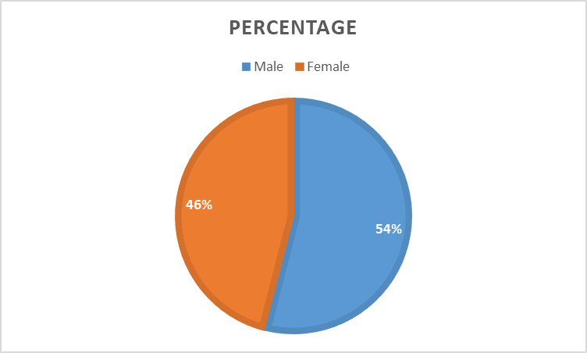

**Fig. No. 1 Gender wise Classification**

**Table No 2. Age Group of the Respondents**

|  |  |
| --- | --- |
| **Age Group** | **Percentage** |
| 20- 30 yrs | 28% |
| 30 – 40 yrs | 38% |
| 40 – 50 yrs | 24% |
| Above 50 yrs | 10% |

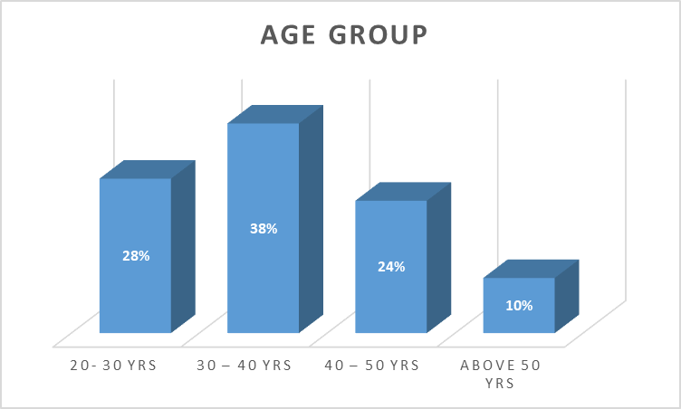

**Fig No. 2 Age Group of the Respondents**

**Table No. 3 Monthly Income of the respondents**

|  |  |
| --- | --- |
| **Monthly Income** | **Percentage** |
| Below Rs.20,000 | 28% |
| 20,000 – 35,000 | 42% |
| 35,000 – 50,000 | 21% |
| Above 50,000 | 9% |

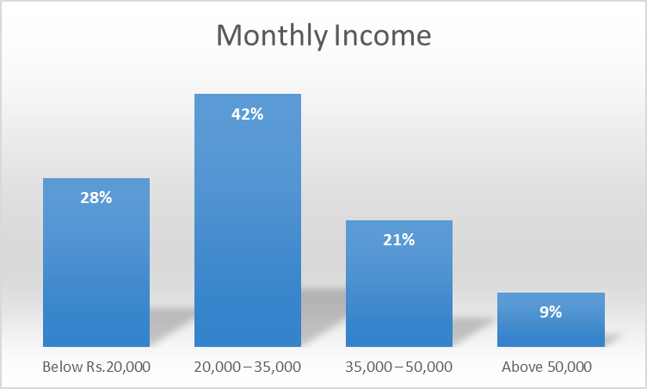

**Figure No. 3 Monthly Income of the respondents**

**Table No. 4 Level of Education**

|  |  |
| --- | --- |
| Education | Percentage |
| Under graduates | 42% |
| Graduates | 38% |
| Post Graduates | 20% |

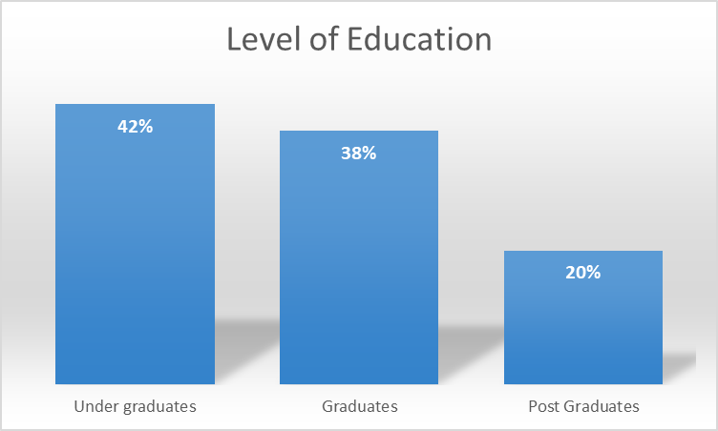

**Figure No. 4 Level of Education**

**6.2 Statistical Analysis**

The relationship between organization culture, HRM practices, Job Satisfaction and Perceived Organizational Performance.

**Table No. 5 Correlation Coefficient**

|  |  |  |  |  |  |
| --- | --- | --- | --- | --- | --- |
|  | | **Organization Culture** | **HRM**  **practices** | **Job Satisfaction** | **Perceived Organization Performance** |
| Organization Culture | Pearson Correlation | 1 | .734** | .654** | .479** |
| Sig. (2-tailed) |  | .000 | .000 | .000 |
| N | 264 | 264 | 264 | 264 |
| HRM practices | Pearson Correlation | .734** | 1 | .695** | .476** |
| Sig. (2-tailed) | .000 |  | .000 | .000 |
| N | 264 | 264 | 264 | 264 |
| Job Satisfaction | Pearson Correlation | .654** | .695** | 1 | .656** |
| Sig. (2-tailed) | .000 | .000 |  | .000 |
| N | 264 | 264 | 264 | 264 |
| Perceived Organization Performance | Pearson Correlation | .479** | .476** | .656** | 1 |
| Sig. (2-tailed) | .000 | .000 | .000 |  |
| N | 264 | 264 | 264 | 264 |

From the above table it is evident that organization culture (.734) and job satisfaction (.654) has significant relationship with HRM practices of the organization and its significant value is (.000). All the dimensions of HRM practices are highly correlated and significant with organization culture, job satisfaction. Organization performance is moderately correlated with organization culture (.479). Perceived organization performance is also moderately correlated with HRM practices and job satisfaction. But all the dimensions are significant at (0.000) level.

**6.3 Multiple Regression**

The linear relationship between independent variables HRM practices, organizational culture, job satisfaction and dependent variable perceived organization performance is obtained through Multiple Regression.

**Table No. 6 Model Summary**

|  |  |  |  |  |
| --- | --- | --- | --- | --- |
| **Model** | **R** | **R Square** | **Adjusted R Square** | **Std. Error of the Estimate** |
| 1 | .934 | .782 | .832 | .314 |

**Predictors: (Constant), HRM Practices, Organization Culture, Job Satisfaction**

The R value indicates that the relationship between Organization Culture, Job satisfaction and HRM practices support was highly correlated. The R square value shows that the predictors predict HRM practices by 78%.

**Table No. 7 Coefficients**

|  |  |  |  |  |  |  |
| --- | --- | --- | --- | --- | --- | --- |
| **Model** | | **Unstandardized Coefficients** | | **Standardized Coefficients** | **t** | **Sig.** |
| **B** | **Std. Error** | **Beta** |
| 1 | (Constant) | .349 | .067 |  | 4.896 | .000 |
| Organization Culture | .239 | .032 | .328 | 8.506 | .000 |
| Job Satisfaction | .241 | .029 | .230 | 6.512 | .000 |
| HRM practices | .302 | .035 | .318 | 8.3065 | .000 |

*Dependent Variable: Perceived Organizational Performance

The coefficients table shows that HRM practices (Beta value = 0.302) are the strongest predictor of perceived organizational performance and it is very highly significant at (0.001) level of significance. The job satisfaction of the employees with (Beta value = 0.241) is the second strongest predictor and is highly significant at (0.001). Organization culture has the lowest beta loading (beta value = 0.239) and is significant at (0.001) level.

**6.4 Recommendations**

The managers and supervisors of the organization has to take the responsibility in creating a unique platform where the employees can showcase their innovations and creative ideas periodically, which results into better performance of the organization. They should also encourage their employees on personal development and growth. The supervisors and managers should work closely with their employees so that the organizational objectives and goals can be achieved.

**6.5 Conclusion**

The study acknowledged the role of supervisors and managers in administering the HRM practices with respect to IT sector in Hyderabad city. It also studied on the influence of job satisfaction and organization culture in the overall performance of the organization. Thus the study concludes that the role of supervisors and managers plays a very important role in implementing HRM practices within the organization.

**References**

[1] Arvey, R. D. (1995). Job satisfaction. In N. Nicholson (Ed.), The Blackwell encyclopedic dictionary of organizational behavior (pp. 272-274). Cambridge, MA: Blackwell.

[2] Barber, G. (1986). Correlates of job satisfaction among human service workers. Administration in Social Work, 10(1), 25-38.

[3] Becker, B., & Gerhart, B. (1996). The impact of human resource management on organizational performance: Progress and prospects. Academy of Management Journal, 39(4), 793-815.

[4] Cho, Y. S. (2004). Examining the impact of human resources management: A performance based analytic model, 65(08), 3054A. (UMI No. 3144524)

[5] Cleveland, J. N., Murphy, K. R., & Williams, R. E. (1989). Multiple uses of performance appraisal: Prevalence and correlates. Journal of Applied Psychology, 74(1), 130-135.

[6] Daley, D., Vasu, M. L., & Weinstein, M. B. (2002). Strategic human resource management: Perceptions among North Carolina County social services professionals. Public Personnel Management, 31(3), 359-375.

[7] Delaney, J. T., & Huselid, M. A. (1996). The impact of human resource management practices on perceptions of organizational performance. Academy of Management Journal, 39(4), 949-969.

[8] Drucker, P. (1999). Management challenges for the 21st century. New York, NY: HarperCollins.

[9] Erbisch, P. S. (2004). Management style, organizational climate, and organizational performance in a mental health agency: An integral model. (Dissertations Abstracts International, 65(11), 4341A. (UMI No. 3154494)

[10] Gelade, G. A., Ivery, M. (2003). The impact of human resource management and work climate on organizational performance. Personnel Psychology, 56(2), 383-404.

[11] Huselid, M. A. (1995). The impact of human resource management practices on turnover, productivity, and corporate financial performance. Academy of Management Journal, 38(3), 635-673.

[12] Keller, R. T., & Szilagyi, A. D. (1976). Employee reactions to leader reward behaviors. Academy of Management Journal, 19(4), 19-27.

[13] Kim, S. (2002). Participative management and job satisfaction: Lessons for management leadership. Public Administration Review, 62(2), 232-241.

[14] Lee, H. (2006). Impact of the civil service reforms on human resources management and job satisfaction determinants. (Doctoral dissertation, Arizona State University). Dissertations Abstracts International, 67(03). (UMI No. 3210162)

[15] Penley, L. E., & Hawkins, B. (1985). Studying interpersonal communication in organizations: A leadership application. Academy of Management Journal, 28(2), 309-326.

[16] Platonova, E. A. (2005). The relationship among human resource management, organizational culture, and organizational performance. Dissertations Abstracts International, 67(01). (UMI No. 3201176)

[17] Selden, S. C. (2005). Human resource management in American counties. Public Personnel Management, 34(1), 59-84.

[18] Sprague, R. W., & Del Brocco, S. F. (2002). Calculating the RIO on internal communication. Employee Relations Today, 29(1), 33-44.

[19] Timm, P. R., & Peterson, B. D. (1993). People at work: Human relations in organizations (4th ed.). St. Paul, MN: West.

[20] Ulrich, D. (1997). Measuring human resources: An overview of practice and a prescription for results. Human Resource Management, 36(3), 303-320.

[21] Dr. A. Ramaraju, “A Role of Innovative Idea Management in HRM”. *International Journal of Management (IJM)*, 5(8), 2014, pp. 25–34

[22] Wahida Begum F, Dr.M. Sheik Mohamed, “A Study on HRM practices and its impact on Job satisfaction and organization performance in BPR Sector, Tiruchirappalli, International Journal of Advanced Research in Management, (IJRAM) Vol 7, Issue3. Decemeber 2016.

[23] Wright, B. E. (2001). Public-sector work motivation: A review of the current literature a revised conceptual model. Journal of Public Administration Research and Theory, 11(4), 559-587.