ROLE OF VITAMIN D IN ORAL HEALTH

Dr. Yogesh P.B.,

Vice Principal and Professor, Dept of Prosthodontics and Crown & Bridge,

Sri Venkateswara Dental College and Hospital,

Chennai, India.

Dr. Rahmath Shameem Shafiullah

Professor, Dept of Prosthodontics and Crown & Bridge,

Sri Venkateswara Dental College and Hospital,

Chennai, India.

Dr. Lidiyal Arunodhayam M.S.,

Lecturer, Dept of Prosthodontics and Crown & Bridge,

Sri Venkateswara Dental College and Hospital,

Chennai, India

Dr. Chandrakala.S,

Assistant Professor, Dept of Prosthodontics and Crown & Bridge,

Sri Venkateswara Dental College and Hospital,

Chennai, India.

Introduction

Absorption, Transport, and Storage of Vitamin D

Dietary sources

Requirements of Vitamin D

Activation of Vitamin D

Biochemical functions

Oral Manifestation of Vitamin D

Oral Complications - Deficiency of Vitamin D

Vitamin D3 (Calcitriol) and Health of Periodontal Tissues

Vitamin D and Osseointegration

References

**Introduction**

Vitamin D is a fat soluble vitamin. It resembles sterols in structure and functions like a hormone. The symptoms of rickets and the beneficial effects of sunlight to prevent rickets have been known for centuries. Hess (1924) reported that irradiation with ultraviolet light induced anti- rachitic activity in some foods. Vitamin D was isolated by Angus (1931) who named it calciferol.

Absorption, Transport, and Storage of Vitamin D

**Site and Process of Absorption**

Vitamin D is absorbed from the mucosa of the duodenum and jejunum.

Bile salts are necessary for absorption of vitamin D.

**Transport of Vitamin D**

It is transported from enterocytes in form of chylomicrons.

It enters lacteals and blood circulation along with chylomicrons.

In plasma, vitamin D binds to α2 globulin. It is transported to body tissues in bound form.

**Storage**

It is stored in the liver.

Dietary sources

Good sources of vitamin D include **fatty fish**, **fish liver oils**, egg yolk etc. Milk is not a good source of vitamin D. Vitamin D can be provided to the body in three ways

1. Exposure of skin to sunlight for synthesis of vitamin D;

2. Consumption of natural foods;

3. By irradiating foods (like yeast) that contain precursors of vitamin D and fortification of foods (milk, butter etc.).

Requirements of Vitamin D

Children = 10 microgram (400 IU)/day;

Adults = 5 to 10 microgram (200 IU)/day;

Pregnancy, lactation = 10 microgram/day;

Senior citizens above the age of 60 = 600 IU per day.

Activation of Vitamin D

Vitamin D functions as a prohormone. After cholecalciferol enters the bloodstream, it is transported to the liver, where it undergoes hydroxylation at the 25th carbon to form 25-hydroxycholecalciferol (25-HCC), the primary storage form. This compound is then carried to the kidneys, where a second hydroxylation occurs at the 1st carbon, producing 1,25-dihydroxycholecalciferol (DHCC), also known as calcitriol. Calcitriol, which has hydroxyl groups at positions 1, 3, and 25, is the biologically active form of vitamin D and acts as a hormone.

Biochemical functions

**Calcitriol** (1,25-DHCC) is the biologically **active** form of vitamin D. It **regulates the plasma** levels of calcium and phosphate. Calcitriol acts at 3 different levels (intestine, kidney and bone) to maintain plasma calcium (normal 9–11 mg/dl).

1. Action of calcitriol on the intestine: In the intestine, calcitriol enhances the absorption of calcium and phosphate. It binds to cytosolic receptors in intestinal cells, forming a calcitriol-receptor complex. This complex enters the nucleus and interacts with specific DNA sequences, promoting the production of calcium-binding proteins that facilitate calcium uptake. This mode of action resembles that of steroid hormones.

2. Action of calcitriol on the bone:

Calcitriol promotes calcium deposition in bones by stimulating osteoblasts to absorb calcium for bone mineralization. Alongside parathyroid hormone (PTH), it also helps mobilize calcium and phosphate from bone stores into the bloodstream, thus elevating plasma calcium and phosphate levels.

3. Action of calcitriol on the kidney: In the kidneys, calcitriol reduces the excretion of calcium and phosphate by promoting their reabsorption, thereby conserving these minerals and supporting blood calcium balance, especially during periods of deficiency.

**24,25-Dihydroxycholecalciferol** (24,25-DHCC) is another metabolite of vitamin D. It is also synthesized in the kidney by 24-hydroxylase. The exact function of 24,25-DHCC is not known. It is believed that when calcitriol concentration is adequate, 24-hydroxylase acts leading to the synthesis of a less important compound 24, 25-DHCC. In this way, to maintain the homeostasis of calcium, synthesis of 24,25-DHCC is also important.

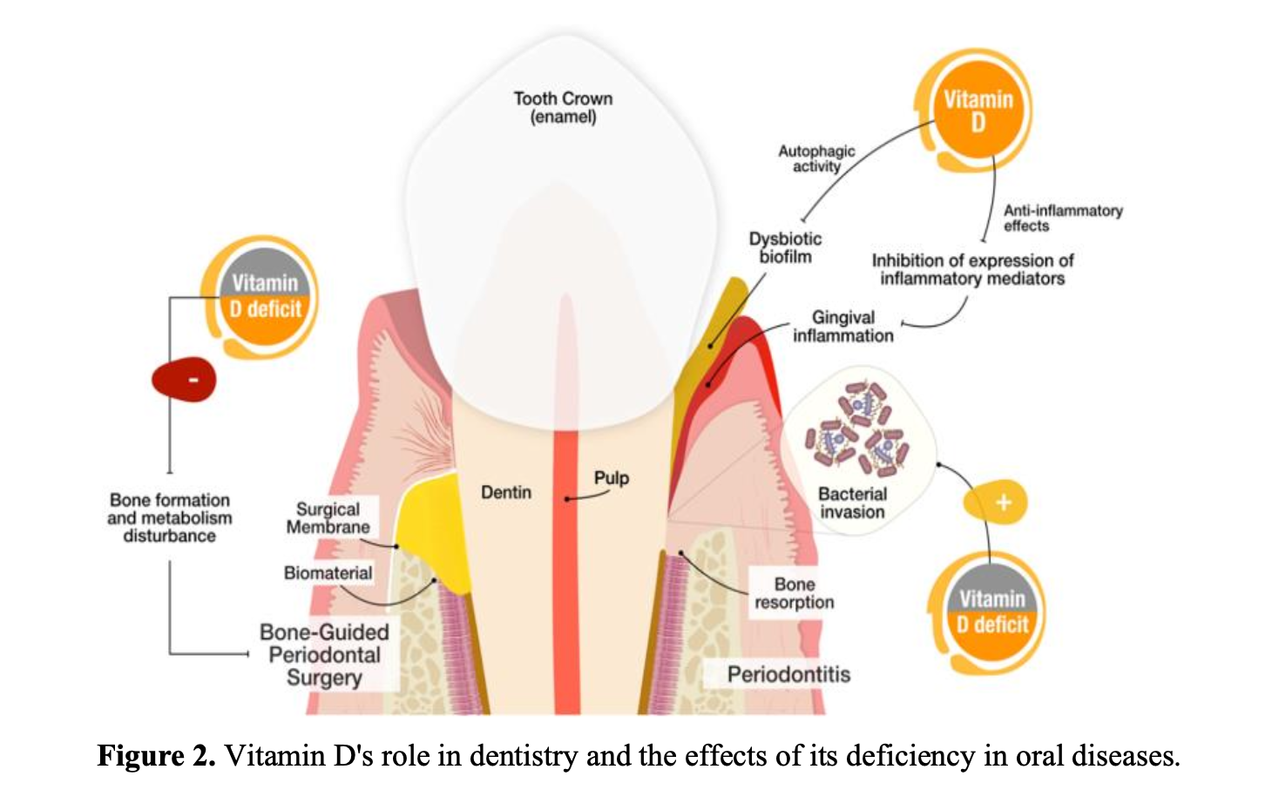

**Figure 1: Role of Vitamin D in Oral Cavity**

Oral Manifestation of Vitamin D

* This essential nutrient plays a crucial role in the development of both the enamel and dentin, as well as in bone formation, with odontoblasts and ameloblasts being its primary target cells.
* In children, tooth eruption delays are commonly caused by nutritional deficiencies, systemic health issues, hormonal imbalances, or syndromes, which can result in conditions like persistent primary teeth (PPT) and delayed tooth eruption (DTE).
* Additionally, vitamin D supplementation increased bone mineral density, which led to slower tooth movement and less relapse in treatment outcomes in Orthodontics.
* Vitamin D significantly contributes to the production of antimicrobial peptides, for example, cathelicidin and defensins, which defend the body against oral pathogens.
* Medication-related osteonecrosis of the jaw (MRONJ) refers to the loss of the underlying bone in the jaw due to necrosis, a severe complication often associated with treatments like bisphosphonates, antiangiogenics, and denosumab, that are prescribed for certain cancers and osteoporosis. Vitamin D may play a key role in bone healing for patients suffering from osteonecrosis linked to bisphosphonates.

Oral Complications - Deficiency of Vitamin D

* Oral impacts of this deficiency include a form of amelogenesis imperfecta during tooth development, alterations in dentin leading to dentinogenesis imperfecta, and ectodermal dysplasia.
* Amelogenesis imperfecta, affecting enamel, can be linked to deficiencies in vitamins A and D or genetic factors, presenting as discoloration and structural alterations.
* Vitamin D deficiency can also trigger decreased bone mineral density, leading to jawbone resorption as mentioned in Figure 1.
* Vitamin D influences the immune system by inducing human cathelicidin (LL-37) in oral epithelial cells, which has antimicrobial and antiendotoxin activities.
* Children with high caries activity show low concentrations of LL-37, emphasizing its role as a “guardian of the oral cavity” and its importance in oral health.
* The active form of vitamin D carries out these actions by binding to the nuclear vitamin D receptor (VDR) in tissues, and since many tumors express VDR, this receptor could influence the development of cancer.
* Oral supplementation of vitamin D has been found to enhance the effectiveness of photodynamic therapy in treating squamous cell carcinoma in mice, suggesting that vitamin D could serve as a valuable, non-toxic adjunct in cancer therapy.
* Vitamin D deficiency is associated with the two most common oral diseases—caries and periodontal diseases. Decreased bone density and progression of periodontal diseases are observed. It is also a risk factor for the development of early childhood caries.
* Vitamin D deficiency leads to inferior lamina dura of both temporary and permanent teeth.
* There is a low mineralization of the dentin, delayed tooth eruption, delayed development and closure of the apex of the root canals, development of peri- apical abscesses of non-cariogenic origin, and trauma of the teeth. A deficiency of this vitamin means that it is possible that the pulp horns are with higher exposure, the pulp chamber is enlarged, and taurodontism is observed.
* Vitamin D significantly contributes to the production of antimicrobial peptides, for example, cathelicidin and defensins, which defend the body against oral pathogens.

Vitamin D3 (Calcitriol) and Health of Periodontal Tissues

**Mineral Homeostasis**

* Calcitriol influences calcium and phosphate homeostasis in the body. It regulates mineralization of mandible and maxilla. So it influences bone density of jaw bones.
* It is necessary for normal bone remodeling.
* It reduces alveolar bone resorption.
* In a clinical trial through randomization by (Garcia et al. 2011), it was observed.
* that supplementation of calcium and vitamin D improved severity of periodontal infection.

**Antibacterial Effect of Calcitriol**

* Calcitriol acts through its vitamin D receptors located on immune cells. It inhibits release of pro-inflammatory cytokines through immune cells.
* It also stimulates macrophages to release peptides. These peptides have antibacterial effect on the microbes responsible for periodontal disease.
* Therefore, calcitriol minimizes incidence of inflammation and infection in periodontal tissue.

Vitamin D and Osseointegration: (Karaoglu, A et al)

* Vitamin D is known to increase osteocalcin, osteopontin, calbindin and 24 hydroxylase levels in bone metabolism, increase extracellular matrix protein formation made by osteoblasts and provide osteoclast activity.
* Vitamin D behind bone formation supports osseoimmunology, which contributes to early healing of implants.
* Some studies suggest that low levels of Vitamin D can negatively affect the osseointegration process in animal models.
* Research also indicates that patients with severe vitamin D deficiency, especially when combined with other risk factors like smoking or periodontal disease, may experience an increased risk of early implant failure.
* Studies have shown that Vitamin D supplementation may enhance new bone formation around implants and improve bone density, especially in individuals with systemic diseases like diabetes mellitus, osteoporosis, and chronic kidney disease (CKD).
* While human clinical studies demonstrating a direct causal link are limited, case reports and some studies suggest that successful implantation has been achieved following Vitamin D supplementation in deficient individuals.
* It is advisable to check a patient's vitamin D levels before dental implant surgery, as low levels might be a risk factor for early implant failure and supplementation is recommended to ensure optimal outcomes.

References

1. Vasudevan DM, Sreekumari S, Vaidyanathan K. Textbook of Biochemistry for Dental Students. 3rd ed. New Delhi: Jaypee Brothers Medical Publishers; 2013.
2. Satyanarayana U, Chakrapani U. Biochemistry for Dental Students. 2nd ed. Kolkata: Elsevier; 2018.
3. Gupta A. Comprehensive Biochemistry for Dentistry: Textbook for Dental Students. 1st ed. New Delhi: Jaypee Brothers Medical Publishers; 2018.
4. Influence of Water- and Fat-Soluble Vitamins on Oral Health in Adolescence, Kristiyana Mineva, Milena Georgieva-Dimitrova, Scripta Scientifica Medicinae Dentalis, 2024;10(1):14-21 Medical University of Varna
5. Botelho J, Machado V, Proença L, Delgado AS, Mendes JJ. A Review of Exploring the Effects of Vitamin D
6. Deficiency on Oral Health and Facial Structures. Int J Dent Res Allied Sci. 2024;4(2):1-8. <https://doi.org/10.51847> QQ4M695DJh
7. Leši´c, S.; Ivaniševi´c, Z.; Špiljak, B.; Tomas, M.; Šoštari´c, M.;Vˇcev, A. The Impact of Vitamin Deficiencies on Oral Manifestations in Children. Dent. J. 2024, 12, 109. <https://doi.org/10.3390/dj12040109.>
8. Karaoglu, A., Pekcetin, Z., Koray, E., Soyer, H. and Koray, M. (2019) The Role of Vitamin D in Implant Success. *Open Journal of Stomatology*, **9**, 260-269. doi: [10.4236/ojst.2019.911027](https://doi.org/10.4236/ojst.2019.911027).
9. Werny, J.G., Sagheb, K., Diaz, L. et al. Does vitamin D have an effect on osseointegration of dental implants? A systematic review. Int J Implant Dent 8, 16 (2022). <https://doi.org/10.1186/s40729-022-00414-6>
10. Buzatu BLR, Buzatu R, Luca MM. Impact of Vitamin D on Osseointegration in Dental Implants: A Systematic Review of Human Studies. Nutrients. 2024 Jan 9;16(2):209. doi: 10.3390/nu16020209. PMID: 38257102; PMCID: PMC10819660.