**COMMUNICATION**

**CONTENT**

* INTRODUCTION
* WHAT IS COMMUNICATION?
* TYPES OF COMMUNICATION
* LEVELS OF COMMUNICATION
* COMMUNICATION BARRIERS
* TOOLS OF EFFECTIVE COMMUNICATION
* THERAPUETIC AND NON THERAPEUTIC TECHNNIQUES
* CONCLUSION

**INTRODUCTION**

**T**he word communication is derived from a Latin word ‘Communis’ which means to share or to participate. Two-way process of reaching mutual⎫ understanding, in which parties involved exchange information, news, ideas and feelings.

.

**Definition:**

* **Webster** defines communication as a process by which information is exchanged between individuals through a common system of symbols, signs or behavior.
* **Millet** defines communication as **“shared understanding of a shared purpose”**

**PURPOSES OF COMMUNICATION**

* To obtain information
* To influence others
* To collect assessment data
* To initiate intervention
* To evaluate outcome of intervention
* To initiate change which helps in promoting health
* To take measures for preventing legal problems associated with nursing practice
* To analyze factors affecting the health team.

**LEVELS OF COMMUNICATION**

**LEVEL - 1  
 (Conventional acquaintances)**

* ***A person communicates with strangers to have casual acquaintances in the conventional level.***
* **Example:** First encounter b/n nurse and the client. Conversation on this level is fairly impersonal. Here, the attempts are made to: be polite, to fill silence, to get acquainted, to relieve tension/stress and to convey incidental information

**LEVEL - 2  
 (exploratory associates)**

* ***Here the conversation is fact and problem oriented.***
* ***Conversation is usually impersonal.***
* **Example:** Relationship with colleagues and neighbours etc.
* Relationship remains on this level for many years.
* Relationship is friendly but not open to very much self-disclosure. E.g. giving health teaching to public.

**LEVEL - 3  
 (participate friends)**

* ***Participate friends means people talk with themselves***
* ***Group is involved in self-disclosure.***
* ***Here the person expresses his own feelings, describes his own experiences and discuss his own ideas.***
* Nurse - patient can reach to this level only if they have developed good reputation

**LEVEL - 4  
 (intimacy:- closest friends)**

* ***At this level, people reveal themselves but not they expose themselves intimately in a way that involves risk.***
* ***Intimate relationships are characterized by communication of feelings and deeply felt mutual understanding***
* **Example:** two close friends

**TYPES OF COMMUNICATION**

**A. Based on relationship**

* + Formal communication
  + Informal communication

**B. Others**

* + visual
  + Telecommunication
  + Meta-communication

**C. Based upon Flow**

* + Downward
  + Upward
  + Horizontal
  + One way
  + Two way

***FORMAL COMMUNICATION***

* **It is the communication between officials on various positions in any organization or institution.**
* **Example: b/w nursing superintendent and staff nurse**
* **It involves transmitting official message within or outside the organization.**

***INFORMAL COMMUNICATION***

* **It is the communication between the two people, may be in social or in organization**
* **Example: interaction b/w two close friends**
* It involves informal talk with the people.
* It is very simple.
* No one can be held responsible for any message**.**

***UPWARD COMMUNICATION***

* Communication occurs from bottom to the top. It may be in form of suggestions, complaints, reports etc.
* It can be verbal or in written form**.**
* **Examples: leave application, suggestions from staff nurses to the Nursing Superintendent for improving the quality care in hospital, Incidental reports.**

**Downward COMMUNICATION**

* It is the communication which occurs from top to bottom such as communication from superior to subordinate to convey information (circular), instructions (policy, rule and regulations) and orders (transfer, promotion etc.)
* **Example: From Nursing superintendent to staff nurses.**

***HORIZONTAL COMMUNICATION***

* **The communication flows horizontally among same hierarchical levels.**
* **Example: Communication among colleagues, lecturers, staff nurses and among clinical instructors.**
  1. *One way communication:* from sender to receiver
  2. *Two way communication:* from both to each other

***VISUAL COMMUNICATION***

* **In this communication message is conveyed using symbols in the form of charts, maps, posters, paintings etc. also known as symbolic communication.**
* **Example: displayed models in exhibition, displayed posters on wall.**

***TELECOMMUNICATION***

* It is the process of communication in distant places with help of electromagnetic appliances.
* **Example: television, radio, internet etc.**

***META COMMUNICATION***

* **This communication occurs in deeper sense. It conveys message within a message etc.**
* **Example: one lady is doing praise of her daughter-in law.**
* One friend is doping praise of her friend. Here, the actual feelings of mother and friend are need to be explored.
* In such communication client’s verbal and non verbal cues may/may not match.

**METHODS OF EFFECTIVE COMMUNICATION**

**Methods of effective communication include:**

* Attending skills: Attentive listening or listening actively using all senses.
* Rapport building skills
* Empathy skills
* Physical attending:Manner of being with another
* All the therapeutic communication techniques
* Confidence
* Critical thinker
* Analytical
* Open minded
* Active listener
* Empathic
* Tactful
* Systematic
* Knowledgeable
* confidentiality

**THERAPEUTIC COMMUNICATION TECHNIQUES:**

* **Using silence**: accepting pauses or silences that may extend for several seconds or minutes without any verbal response. E.g.- Nurse says nothing but continues to maintain eye contact and convey interest .
* **Providing general leads:** use of statements or questions that encourage the client to verbalize. E.g.-”And then what” , “Perhaps you would like to talk”
* **Being specific and tentative:** making statements that are specific rather than general. E.g. – You never care about your health
* **Using open-ended questions:** asking broad questions leading to exploration. E.g.- What brought you to
* **Using touch:** provide appropriate form of touch to reinforce caring feelings.
* **Restating:** repeating the thoughts in similar words as said by the client. E.g.- Patient- I am not sure how I will manage the housework when I get home. My husband expect me to do the cooking and cleaning just like always .
* Nurse – Your husband will expect you to do the cooking and cleaning just like always.
* **Seeking clarification:** making the message of client more understandable. E.g. – Nurse- Let me make sure I understand this correctly . The cost of the medicine keeping you from being able to take it each day?
* **Offering self:** suggesting one’s presence or wish to understand the client. E.g.-” I will walk with you”.
* **Giving information:** Providing factual information in a simple and direct manner. E.g. Visiting hour are…….
* **Acknowledging:** giving recognition of a change of behavior in a nonjudgmental way verbally or non-verbally. E.g.- Praise the patient for self- care activity.
* **Clarifying time or sequence:** helping the client an event, situation, or happening in relationship to time.
* **Presenting reality**: helping the client to differentiate the real from the unreal. E.g.- “I see no one else in the room “.” Your mother is not here: I am a nurse.

**BARRIERS OF COMMUNICATION**

* If nurse does not give importance to the factors affecting communication and communication skills, these will be considered as the barriers of communication.

Following points may interfere to communication process:

* *Physiological Barriers*
* *Psychological Barriers*
* *Environmental Barriers*
* *Cultural Barriers*
* *Non-therapeutic communication techniques*
* *Failure to listen*
* *Improperly decoding the client’s intended message*
* *Placing the nurse’s need’s above the client’s need*

**Non-therapeutic communication techniques**

These are the techniques that inhibit communication are called as the barriers to effective communication.

* **Stereotyping:** offering generalized and oversimplified beliefs about groups of people that are based on experiences too limited to be valid. E.g.-”its for your own good” or difference between girls and boys by the community
* **Agreeing and disagreeing:** giving judgmental response that client is right or wrong. E.g.-”That’s right” and “that’s wrong”
* **Being defensive:** attempting to protect a person or health care services from negative comments. E.g.- “This hospital has a fate reputation”.
* **Challenging:** giving a response that makes clients prove their point of view. E.g.-If you are dead , why your heart is beating?
* **Probing:** asking for information chiefly out of curiosity rather than with intent to assist the client. E.g.- “Tell me your psychiatric history”
* **Testing:** asking questions that make the client admit to something
* **Rejecting:** refusing to discuss certain topics with the client. E.g.-” Lets not discuss” or “ I don’t want to here about….”
* **Changing topics and subjects:** directing the communication into areas of self-interest rather than considering the client’s concerns.
* **Unwarranted reassurance:** using clichés or comforting statements of advice as a means to reassure the client. E.g.- “ It’s going to be alright “

**IEC**

Information ,Education and Communication are inter related to each other. **Information** is the knowledge derived from study, experience or instruction or it is a collection of facts or data and **education** is the both acquisition of knowledge and experience and as well as the development of skills, habits and attitudes which help the person to lead a full and worthwhile life in this universe and **communication** is the interaction between two or more persons that involve exchange of information between sender and receiver. So these three are related to health i.e. information of health related events, education to people regarding health and communicate this in proper way.

**New initiatives in IEC**

* Branding of NRHM through mutli-mediatools( logo, visual ,massage, audio video spots)
* Launch of NRHM newsletter special issues on maternal mortality and immunization published.
* Theme based campaign-immunization week in jan , feb , and march 2006 ,breast feeding ,institutional delivery , save girl child, iodized salt, JSY, profiling of ASHA role and responsibilities ,convergence of health worker-AWW,ASHA, ANM.
* Integration of IEC on AIDS ,RCH ,etc.
* Innovative IEC(use of postal stationary ,use of NRHM health messages in official stationary ,NRHM massages in prescription slips used at PHC ,CHC in states, in melas calendar etc.
* Placement of spots in private satellite channels doordarshan , FM channels, etc.

**Definition:**

‘**’Information, Education and Communication’’**

IEC is a process of working with individuals, communities and societies to develop communication strategies to promote positive behaviors which are appropriate to their settings**.**

**‘’Behavior Change Communication”**

BCC is a process of working with individuals, communities and societies to develop communication strategies to promote positive behaviors which are appropriate to their settings AND provide a supportive environment which will enable people to initiate and sustain positive behaviors**.**

**Broad meaning of BCC:**

* Behavior change communication (BCC) is a process that motivates people to adopt healthy behaviors and lifestyles.
* BCC programs motivate people either to change unhealthy behavior or to continue healthy behavior.
* Many health and development fields use BCC to improve people’s health and well-being, such as family planning & reproductive health, maternal and child health, prevention of infectious diseases, democracy & governance, and poverty alleviation**.**
* **What is the difference between BCC and IEC?**

Experience has shown that providing people with information and telling them how they should behave (“teaching” them) is not enough to bring about behavior change. While providing information to help people to make a personal decision is a necessary part of behavior change, BCC recognizes that behavior is not only a matter of having information and making a personal choice.

* Behavior change also requires a supportive environment.”Behavior change communication” is influenced by “development” and “ health services provision” and that the individual is influenced by community and society. Community and society provide the supportiveenvironment necessary for behavior change.
* IEC is thus part of BCC while BCC builds on IEC.

**Behavior change communication:**

* **BCC is referred to by many names.**
  + IEC
  + Health education
  + Health promotion
  + AIDS education
  + Social Marketing

***Principle of IEC & BCC:***

* Information/education programs may be most effective when applied to problem behaviour.
* Information/education programs designed to “connect” with or modify visitor attitudes, beliefs, or norms are likely to be most effective in the long-term**.**

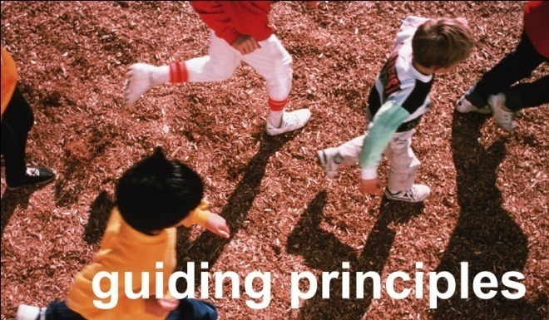

* Use of multiple media to deliver messages can be more effective than useof a single medium.
* Information/education programs are generally more effective with visitors who are less experienced and who are less knowledgeable.
* Strongly worded messages and aggressive delivery of such messages can be an effective way of enhancing the “mindfulness” of visitors, and may be warranted when applied to issues such as visitor safety and protection of critical and/or sensitive resources.
* Non agency media, such as newspapers, magazines, and guidebooks can be effective
* Information on the impacts, costs, and consequences of problem behaviors can be an effective information/ education strategy.
* Role modeling by volunteers can be an effective information/education strategy.
* Personal contact with visitors by rangers or other employees can be effective in communicating information/ education.
* Messages should be targeted to specific audiences to the extent possible.

**Behavior change- A need for prevention** 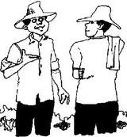

* Behavior determines whether a person is at risk or not.
* Those with risky behavior need to change their risky behavior to safe behaviors.
* Those with safe behaviors need to maintain existing behaviors.
* Targeted interventions aim behavior change of people with risky behaviors.

**Change in behavior is the ultimate goal of targeted interventions**

**Behavior change can take place at the individual, community and societal level** 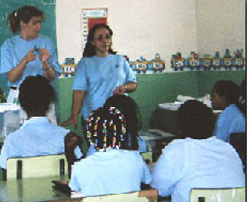

**BCC- Salient features:**

* Behaviour change communication uses a science based approach to communication that involves behavioural sciences, social learning, persuasion theory to achieve realistic targets.
* Recognises that behaviour change is much a societal process as it is an individual decision making process. Emphasises on audience involvement and participation throughout the BCC process**.**
* Appreciation of the crucial role of environment to capture attention, interest and most importantly emotions to make learning and change a pleasurable experience.
* Focus on sustainability of communication messages and strategies.
* Behaviour change is a goal, but people move through several stages and steps before they change behaviour.

**An introduction to BCC programs:**

* Before designing a BCC intervention/strategy, it is important to be clear about exactly whose behavior is to be influenced and which aspect of their behavior should be the focus for change.
* Communities are made up of different groups with different risk and vulnerability factors. Even within the same broad group, there may besubgroups with distinct characteristics. Different target groups will require different approaches.
* Therefore, when making decisions about which target groups and which factors to address, it is necessary to consider:
* which target groups are most vulnerable;
* which risk / vulnerability factors are most important;
* which factors may be related to the impact of conflict and displacement;
* what could be motivators for behaviour change;
* what could be barriers to behaviour change;
* what type of messages will be meaningful to each target group.
* which communication media would best reach the target group;
* which services/resources are accessible to the target group;

*Behavior change is a continuous process*

* *Not all individuals go through the same*

**Steps of the process in the same order, speed or time**

* People at different steps require different messages and sometimes different approaches.
* As knowledge and approval reaches high levels, BCC emphasis must shift to later steps
* Identifying cues for action
* Maximizing access and quality of services
* Identifying and removing barriers to change
* Creating opportunities for increased peer advocacy

**BCC alone is not enough:**

* Social norms and public policies influence behavior change. A strategic shift must be also be attempted simultaneously.
* Behavior change communication is not a stand alone strategy.
* It has to be used in conjunction with other strategies such as STD treatment, condoms and creation of enabling environment
* BCC often complements and supports other prevention strategies and approaches

**Cycle consists of :**

**PLANNING**

**DESIGN**

**FEEDBACK**

**EVALUATION**

**PRODUCTION**

**DISTRIBUTE**

**PLANNING :**

* Identify problems and causes
* Identify problems that IEC/HE can tackle
* Decide strategies ,possible media and target audience
* Produce guidelines on use of material
* Produce draft distribution plan.

**DESIGN**

* Engage designer
* Decide message /slogan
* Review drafts of massage /slogan
* Engage artist /illustrator
* Pretest materials
* Summarize &review results of pretest

**PRODUCTION**

* Finalize material
* Produce artwork
* Subcontract-orientation and printing
* Finalize distribution plan

**DISTRIBUTE**

Distribute material and monitor effects

**FEEDBACK**

* Review and reports /summarize results
* Review results and summarization
* Distribute and discuss results and proposed actions.

**EVALUATION**

* Design evaluation tools
* Conduct evaluation and distribute results

**Theories About Behavior Change**

**Health Belief Model**

Assumes that people change their behavior according to whether or not they believe themselves to be at risk

**For example**

In order to use condom an individual must believe that he or she is at risk of HIV , feel that HIV is serious and believe that HIV transmission can be prevented by using condom

* **Social learning theory**

Assumes that behavior change is the result of interaction between personal factors(knowledge , skill, self efficacy, self control)and environmental influences (family, social support and expectation)using this model.

* **Cognitive behavior theory**

Assumes that people need skills as well as information.IEC activities based on this theory emphasis educational interventions which include activities to personalize information ,training in decision making and assertiveness and practice in applying these skills

* **PEN-3 Model**

It is based on the idea that health education is a dynamic process involving the individual ,family , and community and behavior are divided into positive or beneficial ,exotic and negative .Negative behavior are identified appropriate target for change.

**Stage of behavior change**

* **PRECONTEMPLATION:** changing a behavior has not been considered; person might not realize that change is possible or that it might be of interest to them.
* **CONTEMPLATION:** something happens to prompt the person to start thinking about change - perhaps hearing that someone has made changes - or something else has changed - resulting in the need for further change.
* **PREPARATION:** person prepares to undertake the desired change – requires gathering information, finding out how to achieve the change, ascertaining skills necessary, deciding when change should take place - may include talking with others to see how they feel about the likely change, considering impact change will have and who will be affected.
* **ACTION**: people make changes, acting on previous decisions, experience, information, new skills, and motivations for making the change.
* **MAINTENANCE:** practice required for the new behavior to be consistently maintained, incorporated into the repertoire of behaviors available to a person at any one time.

**3 Main methods of communication channels in BCC:**

1. Interpersonal channels, often one-to-one communication, such as counseling and telephone hotlines.
2. Mass media channels, which can reach large audiences. Examples:include radio and television, widely circulated newspapers and magazines, billboards and bus advertising, and the Internet

(3) Community channels, which include rallies, public meetings, and folk dramas and also local newspapers and local radio stations.

**Seven ‘C’s of communication:**

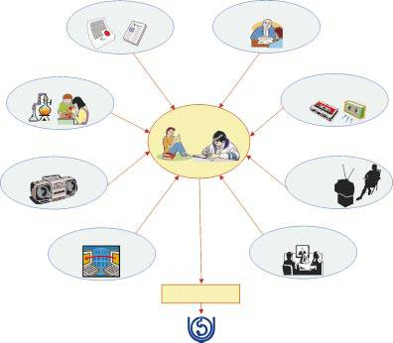

**Command Attention**

Only messages that are noticed and remembered can be effective. Messages need to attract attention and elicit comments. Peer educators talking about HIV/AIDS should be received by their peers as an important issue**.**  

**Cater to the Heart and head**

* Most people are moved at least as much by emotion as much as reason.
* A message that arouses emotion are effective because people learn better when their emotions are aroused.
* Emotions can be aroused by story telling, reflecting however briefly on the individual or group.
* Appeal to reason at the same time adds staying power to the message and consolidates the thought process.

**Clarify the message**

* Focus and freedom from clutter are important. A message should convey a single important point. Ancillary information and multiple themes distract and some may simply miss the point.

**Communicate a benefit**

People need a strong motive to change their behaviour. The best motivator is the expectation of a personal benefit. People rarely use a clean needle or a condom, unless they see practical benefit in it. “The factories make the condoms… the peers sell hope for life”.

**Create trust**

* A message that people will act on their own accord must come from sources they trust. If the promise of trust does not come from a credible source, they will not believe it. It is important for the source to be available to support any need arising as a result of the trial of the messages given by them.

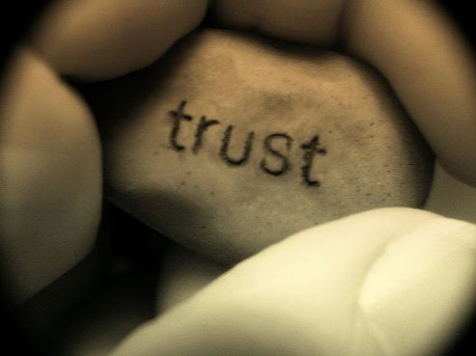

**Call for action**

* After seeing or receiving a message, people should know exactly what they should do. Once convinced that the promised benefit is worth pursuing, people need to know how to act on this belief ; where to go, what to do, what to buyand how to use. Directives should be clearly stated. Without a specific cue for action, people may hear, understand and even approve of a message but still take no action

**Consistency counts**

* Repetition is essential. The same message repeated with variations, but with basic consistency, becomes familiar and acceptable.

**CONCLUSION**

* Information, education and communication is a process which make the public aware and enhance their knowledge regarding health issues as well as other information of health services and Govt. schemes which are accessible for them**.**
* Behavior change communication (BCC) is a process that motivates people to adopt healthy behaviors and lifestyles. Behaviour change communication uses a science based approach to communication that involves behavioural sciences, social learning, persuasion theory to achieve realistic targets.Recognises that behaviour change is much a societal process as it is an individual decision making process. Emphasises on audience involvement and participation throughout the BCC process**.**

**REFERENCES**

* **Book references**
* R Pramila, “nursing communication educational technology”, Edition 1st, Jaypee brothers publisher, pp-431
* Baswanthapa BT, “Nursing Education”, Edition 2nd, Jaypee brothers publisher, pp-584
* Neeraja KP, “Nursing Education”, Edition 2nd, Jaypee brothers publisher, pp-584

**Net references**

* The Drum Beat to the Editor - Deborah Heimann [dheimann@comminit.com](mailto:dheimann@comminit.com)
* Ketevan Goguadze [k.goguadze@curatio.com](mailto:k.goguadze@curatio.com) OR Anton Luchitsky [aluchitsky@path.org](mailto:aluchitsky@path.org)